**A Dual-Feature System: Gesture-to-word using CNN and Speech-to-text conversion**

***A Project Report submitted***

***in partial fulfillment of the requirements***

***for the award of the degree of***

**BACHELOR OF TECHNOLOGY**

***In***

**COMPUTER SCIENCE & ENGINEERING**

***By***

1.Shahanawaz Sulthana – 21B01A05G4 3. Tadepalli Harika Naga Durga – 21B01A05H5

2. Shaik Faheem Maharoor - 21B01A05G5 4. Vemavarapu Nag Sahithi – 21B01A05J0

5. Vidiyala Rithu Sree – 21B01A05J1

***Under the esteemed guidance of***

**Dr. P. Kiran Sree, MTech, Ph.D.**

**HOD & Professor**



**DEPARTMENT OF COMPUTER SCIENCE & ENGINEERING**

**SHRI VISHNU ENGINEERING COLLEGE FOR WOMEN(A)**

**(Approved by AICTE, Accredited by NBA & NAAC, Affiliated to JNTU Kakinada)**

**BHIMAVARAM – 534 202**

**2024 – 2025**

**BHIMAVARAM – 534 202**

**SHRI VISHNU ENGINEERING COLLEGE FOR WOMEN(A)**

**(Approved by AICTE, Accredited by NBA & NAAC, Affiliated to JNTU Kakinada)**

**BHIMAVARAM – 534 202**

**DEPARTMENT OF COMPUTER SCIENCE & ENGINEERING**



**CERTIFICATE**

*This is to certify that the project entitled “****A Dual-Feature System: Gesture-to-word using CNN and Speech-to-text conversion****”, is being submitted by* ***Shahanawaz Sulthana, Shaik Faheem Maharoor, Tadepalli Harika Naga Durga, Vemavarapu Nag Sahithi, Vidiyala Rithu Sree,*** *bearing the* ***Regd. No. 21B01A05G4, 21B01A05G5, 21B01A05H5, 21B01A05J0, 21B01A05J1*** *in partial fulfillment of the requirements for the award of the degree of “****Bachelor of Technology*** *in* ***Computer Science & Engineering****” is a record of Bonafide work carried out by her under my guidance and supervision during the academic year 2024–2025 and it has been found worthy of acceptance according to the requirements of the university.*

**Internal Guide Head of the Department**

**External Examiner**

**ACKNOWLEDGMENT**

The satisfaction that accompanies the successful completion of any task would be incomplete without the mention of the people who made it possible and whose constant encouragement and guidance has been a source of inspiration throughout the course of this seminar. We take this opportunity to express our gratitude to all those who have helped us in this seminar.

We wish to place our deep sense of gratitude to **Sri. K. V. Vishnu Raju, Chairman of SVES**, for his constant support on each and every progressive work of mine.

We wish to express our sincere thanks to **Dr P Srinivasa Raju garu, Director, Student Affairs, Admin, SVES, Bhimavaram**for being a source of inspiration and constant encouragement.

We wish to express our sincere thanks to **Dr. G. Srinivasa Rao, Principal of SVECW** for being a source of inspiration and constant encouragement.

We wish to express our sincere thanks to **Prof P. Venkata Rama Raju, Vice-Principal of SVECW** for being a source of inspirational and constant encouragement.

We wish to place our deep sense of gratitude to **Dr. P. Kiran Sree, Head of the Department** **of Computer Science & Engineering** for his valuable pieces of advice in completing this project successfully.

We are deeply indebted and sincere thanks to our PRC members **Dr. K. Ramachandra Rao, Dr. P. R. Sudha Rani, Dr. R. Anuj, Dr. N. Silpa** for their valuable advice in completing this project successfully.

We are deeply thankful to our project coordinator **Dr. P. R. Sudha Rani, Professor** for her indispensable guidance and unwavering support throughout our project’s completion. Her expertise and dedication have been invaluable to our success.

Our deep sense of gratitude and sincere thanks to **our guide** **Dr. P. Kiran Sree, Head of the Department** **of Computer Science & Engineering** for his unflinching devotion and valuable suggestions throughout my project work.

Project Associates:

1.21B01A05G4 - Shahanawaz Sulthana

2.21B01A05G5 - Shaik Faheem Maharoor

3.21B01A05H5 - Tadepalli Harika Naga Durga

4.21B01A05J0 - Vemavarapu Nag Sahithi

5.21B01A05J1 – Vidiyala Rithu Sree

**ABSTRACT**

Effective communication is essential for social integration, yet individuals who are deaf or mute often face barriers in expressing themselves. Traditional communication methods, such as sign language, are not universally understood, limiting their ability to interact seamlessly. This project presents an innovative dual feature real-time system that bridges this gap by translating both hand gestures and spoken language into text, enhancing accessibility for individuals with speech and hearing impairments.

The proposed system employs Convolutional Neural Networks (CNNs) for accurate hand gesture recognition, enabling seamless translation of sign language into word. OpenCV is utilized to detect and track hand movements, ensuring real-time processing. Additionally, speech recognition is integrated using Python libraries such as SpeechRecognition and Google Web Speech API, allowing spoken words to be transcribed into text with high accuracy. By combining deep learning-based gesture recognition with speech-to-text conversion, this dual-feature system provides a robust, multimodal platform.

The utilization of CNNs, specifically the concept of transfer learning using MobileNet architecture, enhances the precision of gesture classification while maintaining computational efficiency, making it suitable for real-time applications. Additionally, the integration of speech processing technology enables accurate language interpretation. This real-time approach enhances user interaction by providing seamless and intuitive accessibility, reducing reliance on external assistance. The system’s efficiency in recognizing diverse input modalities makes it a valuable tool for fostering inclusivity and accessibility.

In conclusion, this project demonstrates the potential of deep learning and computer vision to create an inclusive framework. By integrating gesture and speech recognition, it eliminates barriers for individuals with disabilities, promoting a more connected and accessible environment.

**Table Of Contents**

**S. No** **Topic** **Page No**

1. Introduction 6 – 8
2. System Analysis 9 – 13

2.1 Existing System

2.2 Proposed System

2.3 Feasibility Study

1. System Requirements Specification 14 - 19

3.1 Software Requirements

3.2 Hardware Requirements

3.3 Functional Requirements

1. System Design 20 - 31

4.1 Introduction

4.2 Data flow diagrams (or) UML Diagrams

1. System Implementation 32 - 52

5.1 Introduction

5.2 Project Modules

5.3 Algorithms

5.4 Screens

1. System Testing 53 – 83

6.1 Introduction

6.2 Testing Methods

6.3 Test Cases

1. Conclusion 84 – 86
2. Bibliography 87
3. Appendix 88 - 102
   1. Introduction to Python
   2. Introduction to Convolutional Neural Network (CNN) Algorithm
   3. Introduction to Introduction to MobileNet Architechture
   4. Introduction to Introduction to HTML
   5. Introduction to CSS
   6. Introduction to JavaScript
   7. Introduction to Flask Framework
   8. Introduction to Transfer Learning Architecture

**1. INTRODUCTION**

Hand gesture and speech recognition play a crucial role in assisting individuals with speech or hearing impairments, enabling them to communicate more effectively with their surroundings. Traditional communication methods, such as sign language, require knowledge and understanding from both the sender and the receiver, which may not always be feasible in diverse social and professional settings. This project aims to bridge this communication gap by developing a real-time, deep learning-based system that translates hand gestures and spoken language into text, thereby enhancing accessibility and inclusivity.

To achieve this, the system integrates computer vision techniques for gesture recognition and speech processing algorithms for voice-to-text conversion. The hand gesture recognition module leverages MobileNet, a lightweight convolutional neural network (CNN) known for its efficiency and high accuracy in resource-constrained environments. The model is trained using a dataset of American Sign Language (ASL) gestures, ensuring accurate classification of hand signs that correspond to specific letters, forming words and sentences. Transfer learning is employed to enhance model performance by utilizing pre-trained knowledge, enabling effective recognition even with a limited training dataset.

Alongside gesture recognition, the speech-to-text module utilizes Python libraries such as SpeechRecognition and the Google Web Speech API to transcribe spoken language into text. This dual-input approach allows users to communicate using either gestures or speech, making the system more versatile and user-friendly. Additionally, OpenCV framework is employed for efficient real-time hand tracking and feature extraction, ensuring smooth processing and accurate gesture detection.

One of the key challenges in gesture and speech recognition is adapting to diverse environments and user variations. To address this, the system incorporates data augmentation techniques to improve model generalization across different lighting conditions, backgrounds, and hand positions. Furthermore, model performance is evaluated using key metrics such as accuracy, precision, recall, and response time, ensuring robustness and reliability in real-world scenarios.

The integration of deep learning for gesture recognition and speech processing offers a practical, multimodal communication tool that significantly enhances accessibility for individuals with speech or hearing impairments. By combining efficiency, accuracy, and real-time processing, this project aims to contribute towards a more inclusive society where communication barriers are minimized. The system's adaptability also makes it suitable for various applications, including education, assistive technology, human-computer interaction, and smart home automation.

Through this approach, the project not only addresses accessibility challenges but also demonstrates the potential of artificial intelligence in transforming assistive technologies. Future enhancements may include expanding the dataset for more comprehensive gesture recognition, integrating natural language processing (NLP) for contextual understanding, and deploying the system on edge devices for enhanced portability and real-world usability.

**2. System Analysis**

**2.1 Existing System:**

Existing systems designed to assist individuals with speech and hearing impairments primarily focus on either sign language translation or speech-to-text conversion. However, these systems have limitations that reduce their effectiveness and accessibility.

Sign language translation systems typically rely on wearable sensors to capture and analyze hand gestures, converting them into text or speech. While these systems help bridge the communication gap for individuals using sign language, they often suffer from real-time processing limitations, making interactions slower and less efficient. Furthermore, wearable sensor-based solutions can be expensive, requiring specialized gloves or motion sensors, which restrict their accessibility to a broader audience.

Additionally, these systems focus solely on gesture-based communication without incorporating speech recognition, which prevents them from supporting individuals with both speech and hearing impairments simultaneously.

On the other hand, speech-to-text systems, such as Google’s Speech-to-Text API, provide real-time transcription of spoken words, helping individuals with hearing impairments understand conversations. However, these systems do not assist those who cannot speak, limiting their usability in a multi modal scenario. Another major limitation is that speech recognition systems struggle in noisy environments, making them less reliable in real-world applications where background noise can interfere with accuracy.

**2.2 Proposed System:**

The proposed system, "A Dual-Feature System: Gesture-to-Word using CNN and Speech-to-Text Conversion," is designed to bridge gaps for individuals with speech and hearing impairments by integrating real-time gesture recognition and speech-to-text conversion into a single, accessible platform.

For gesture recognition, the system utilizes OpenCV and Convolutional Neural Networks (CNNs), specifically employing the MobileNet architecture. MobileNet is chosen for its lightweight design and computational efficiency, enabling real-time processing of hand gestures with minimal resource consumption. This ensures smooth and accurate classification, making the system suitable for use on various devices, including mobile platforms.

For speech-to-text conversion, the system incorporates SpeechRecognition and the Google Web Speech API to transcribe spoken language into text. This feature enables individuals with hearing impairments to understand spoken communication in real time, ensuring effective interaction in different environments.

The system features a user-friendly interface, designed with accessibility in mind. It includes two clearly labeled buttons, one for gesture processing and another for speech processing allowing users to interact with the platform effortlessly. This ensures an intuitive and seamless experience, even for individuals with limited technical knowledge.

A key advantage of this system is its dual-feature integration, enabling users to switch between gesture-based and speech-based interaction as needed. The real-time processing capability ensures minimal latency, providing instant feedback for both gesture and speech recognition.

By combining deep learning-powered gesture recognition with efficient speech-to-text conversion, the proposed system offers a comprehensive assistive tool that enhances accessibility and promotes social inclusion.

**2.3 Feasibility Study:**

A feasibility study, sometimes called a feasibility analysis or feasibility report, is a way to evaluate whether or not a project plan could be successful. A feasibility study evaluates the practicality of yourproject plan in order to judge whether or not you’re able to move forward with the project.

Uses Of Feasibility studies:

Feasibility studies can be very helpful for guiding a community's decision-making process. They can provide neutral, third-party professional analysis including cost-benefit analysis, alternative options and verification

This is possible only if it is feasible within limited resources and time. The different feasibilities that have to be analyzed are:

• Technical Feasibility

• Economic Feasibility

• Operational Feasibility

The feasibility study aims to assess the viability of implementing the proposed system, "A Dual-Feature System: Gesture-to-Word Using CNN and Speech-to-Text Conversion," within real-world applications. This study evaluates various factors to determine whether the project is feasible and economically viable.

**Technical Feasibility:**

Technical feasibility assesses whether the proposed system can be successfully developed and implemented using available technology and resources. Factors considered include:

* Compatibility: The system will be developed using Python, TensorFlow, Keras, OpenCV, and SpeechRecognition libraries, which are widely used and supported technologies. These technologies are compatible with most modern computing platforms and can be easily integrated into existing applications or standalone interfaces.
* Scalability: The architecture of the system is designed to be scalable, allowing for future enhancements such as support for additional languages, gestures, and improved model accuracy. Cloud-based solutions like Google Web Speech API ensure flexibility in handling large-scale speech data. The gesture recognition model, built using CNN and MobileNet, can be fine-tuned for new datasets, making the system adaptable to different environments and use cases.
* Development Tools: The required development tools, including Python frameworks (TensorFlow, Keras) for deep learning and OpenCV for image processing, are freely available as open-source software. There is ample documentation and community support available, ensuring ease of implementation and troubleshooting.

**Economic Feasibility:**

Economic feasibility evaluates whether the system is cost-effective to develop and maintain in the long run. Factors considered include:

* Development Costs: Since the project relies on open-source tools and libraries (Python, TensorFlow, OpenCV, Google APIs), there are no licensing costs involved. Hardware requirements are minimal, with the system being capable of running on a standard computer with a webcam and microphone.
* Operational Costs: Once deployed, the system incurs minimal operational costs. The speech-to-text module utilizes Google Web Speech API, which offers a free tier for limited usage, making it cost-efficient. Additionally, local processing of gesture recognition minimizes cloud dependencies, reducing long-term expenses.
* Return on Investment (ROI): The system provides significant value by bridging communication gaps for the deaf and/or dumb community. Its potential applications in education, healthcare, and customer service sectors make it a worthwhile investment, enhancing inclusivity and accessibility.

**Operational Feasibility:**

Operational feasibility determines whether the system can be successfully integrated and utilized by end users. Factors considered include:

* User-Friendliness: The system is designed to be intuitive, allowing users to interact through a simple interface that captures gestures via a webcam and transcribes speech in real time. The goal is to ensure ease of use, even for individuals with minimal technical expertise.
* Training and Support: Minimal user training is required, as the system operates in an automated manner. Comprehensive documentation and user guides will be provided for effective onboarding.
* Reliability and Accuracy: The CNN-based gesture recognition model and the Google Web Speech API are known for their high accuracy in real-world conditions. Continuous training and updates will further enhance system reliability.

**3.System Requirements Specification**

3. System Requirements Specifications

**3.1 Software Requirements**

**Development Environment:**

* **Python:** Python is an open-source, high-level, interpreted programming language known for its readability and versatility. It serves as the runtime environment for the application, enabling server-side scripting and logic execution. Python’s extensive standard library and third-party packages make it ideal for web development, data processing, and integration with machine learning frameworks. Its simplicity and robust ecosystem, managed through tools like `pip` (Python Package Installer), support rapid development and deployment of scalable applications. In this project, Python powers the Flask web server and integrates with libraries for computer vision, speech recognition, and database connectivity.
* **Flask:** Flask is a lightweight and flexible micro web framework for Python, designed to simplify the development of web applications and APIs (Application Programming Interfaces). It provides essential tools for handling HTTP requests, routing, templating, and session management, while remaining unopinionated, allowing developers to structure their code as needed. Flask’s minimalistic design, combined with its extensibility through extensions and middleware, makes it an excellent choice for building small to medium-sized web applications.
* **MySQL Connector:** MySQL Connector/Python is an official driver provided by MySQL for connecting Python applications to MySQL databases. It enables seamless interaction with the MySQL server, allowing the application to perform CRUD (Create, Read, Update, Delete) operations on the database. This connector is lightweight, easy to configure, and supports secure database connectivity, making it suitable for managing user authentication and recording data in this project.
* **Visual Studio Code**: A highly customizable, lightweight IDE with support for Python extensions, debugging tools, and integrated Git.

**Database:**

* **XAMPP with MySQL**: XAMPP is an open-source software stack that provides a comprehensive development environment for web applications, including Apache (web server), MySQL (database), PHP, and Perl. In this project, MySQL, bundled within XAMPP, serves as the relational database management system (RDBMS) and uses Structured Query Language (SQL) for data management. MySQL within XAMPP offers a robust, scalable, and efficient solution for storing structured data, such as user credentials and audio recordings. The database schema includes tables like users (for authentication) and recordings (for storing audio metadata). XAMPP’s integrated MySQL provides a user-friendly interface via phpMyAdmin for database administration, along with reliable performance and widespread adoption, making it an ideal choice for local development and testing in this project. It is seamlessly integrated into the application using the MySQL Connector/Python library, enabling CRUD (Create, Read, Update, Delete) operations from the Flask application.

**Frontend Dependencies:**

* **Bootstrap:** Bootstrap is an open-source front-end framework that provides pre-designed HTML, CSS, and JavaScript components for building responsive, mobile-first web interfaces. It includes a flexible grid system, UI elements (e.g., buttons, forms), and utilities that enhance the application’s user interface. Bootstrap’s compatibility with Jinja2 templates allows for rapid styling and layout design, ensuring a consistent and professional look across devices. (Note: While not explicitly used in the code, it’s recommended for frontend enhancement.)
* **HTML**: HyperText Markup Language (HTML) is the standard markup language used to structure content on the web. It forms the backbone of the application’s frontend, defining the layout and elements of web pages such as forms, buttons, and headings. In this project, HTML is used within Jinja2 templates (e.g., home.html, login.html, register.html) to create the user interface, including login and registration forms, audio recording displays, and navigation elements. HTML’s simplicity and compatibility with Flask’s templating engine enable dynamic content generation, ensuring a structured and accessible presentation of data to users across browsers.
* **CSS**: Cascading Style Sheets (CSS) is a stylesheet language used to define the visual presentation of HTML elements, enhancing the application’s aesthetics and usability. It controls properties like colors, fonts, layouts, and responsiveness, ensuring a polished and consistent look for pages rendered by Flask. In this project, CSS styles static assets and Jinja2 templates, improving the appearance of forms, buttons, and recording lists (e.g., in recordings.html). While custom CSS can be applied via the static/ directory, integrating it with a framework like Bootstrap is recommended for streamlined design and responsiveness.
* **JavaScript**: JavaScript is a high-level, interpreted programming language that adds interactivity and dynamic behavior to web pages. It runs in the client’s browser, enabling features like form validation, real-time updates, and event handling. In this application, JavaScript can enhance routes like /mic (e.g., handling file uploads asynchronously) and /open_webcam (e.g., interacting with browser APIs for webcam access). While not heavily utilized in the current server-side Flask code, JavaScript is essential for client-side enhancements and can be included via the static/ directory or external libraries, complementing Jinja2’s server-side rendering.

**Web Server:**

* **XAMPP with Apache**: XAMPP is an open-source software stack designed to simplify web development by bundling essential tools, including Apache (web server), MySQL (database), PHP, and Perl. In this project, Apache, provided within XAMPP, serves as the web server responsible for handling HTTP requests and delivering web content to clients. Apache is a robust, scalable, and widely-used open-source web server software known for its reliability, flexibility, and extensive module support. It processes requests from the Flask application, serving static files (e.g., from the static/uploads/ directory) and routing dynamic requests to the Flask framework via a WSGI (Web Server Gateway Interface) bridge, such as mod_wsgi (if configured). XAMPP’s Apache includes a user-friendly control panel for starting/stopping the server and managing configurations, making it an excellent choice for local development and testing. Its seamless integration with the development environment ensures efficient serving of web pages like home.html, login.html, and prediction.html, enhancing the application’s accessibility during the development phase.

**Version Control:**

* **Git:** Git is a distributed version control system used to track changes in the codebase, enabling collaboration and version management. It allows developers to create branches, merge changes, and revert to previous states, ensuring a robust development workflow.
* **GitHub:** GitHub is a web-based platform for hosting Git repositories, providing tools for collaboration, code review, and project management. Key features include:
* **Repository Hosting:** Stores the project’s source code in a centralized location.
* **Collaboration Tools:** Supports pull requests, issues, and code reviews for team contributions.
* **Documentation:** Hosts README files and wikis for project guidance.

GitHub’s community and extensibility make it an ideal choice for managing this project’s codebase.

**Other Dependencies:**

* **pip:** pip is the default package manager for Python, used to install and manage third-party libraries and dependencies listed in a `requirements.txt` file. It simplifies the setup of the development environment by allowing developers to install packages like Flask, MySQL Connector, and others with a single command (`pip install -r requirements.txt`). pip ensures version compatibility and dependency resolution, streamlining the deployment process.
* **OpenCV (cv2):** OpenCV is an open-source computer vision library used in the application for webcam-related functionality (e.g., in `live.py`). It provides tools for image and video processing, making it essential for the `/open_webcam` route.
* **SpeechRecognition:** The SpeechRecognition library enables audio transcription in the `/mic` route by interfacing with APIs like Google Speech Recognition. It processes uploaded audio files and converts them to text, storing the results in the database.
* **TensorFlow/Keras:** These libraries provide machine learning capabilities, potentially used in `live.py` for gesture recognition or classification tasks via pre-trained models. They integrate with OpenCV for real-time processing.
* **cvzone**: A computer vision library that extends OpenCV with modules like `HandTrackingModule` and `ClassificationModule`, likely used in the webcam feature for gesture detection.
* **Subprocess:** The `subprocess` module allows the application to spawn external Python scripts (e.g., `live.py`) from the `/open_webcam` route, enabling modular execution of webcam-related functionality.

**3.2 Hardware Requirements:**

Hardware requires software to run correctly. Without the correct hardware, your software may not run efficiently or at all. It is important to consider both when making decisions about your IT systems, as this can affect the way you work, your productivity and your business bottom line.

Hardware requirements are:

* Processor - I5 and above
* RAM - 8 GB
* Hard Disk - 256 GB
* Internet: Stable connection for data access and updates
* Peripherals: Basic monitor, keyboard, and mouse for interaction

**3.3 Functional Requirements:**

Functional requirements are the desired operations of a program, or system as defined in software development and systems engineering. The systems in systems engineering can be either software electronic hardware or a combination of software-driven electronics. These are the requirements that the end user specifically demands as basic facilities that the system should offer. All these functionalities need to be necessarily incorporated into the system as a part of the contract. These are represented or stated in the form of input to be given to the system, the operation performed and the output expected.

The functional requirements for this application are:

1. Gesture Recognition in Real Time: The system should detect and recognize hand gestures of alphabets instantly.

2. Convert Recognized Gestures into Words: Recognized hand gestures should be converted into corresponding alphabets forming word/words.

3. Speech Recognition in Real Time: The system should accurately recognize spoken words.

4. Convert Recognized Speech into Text: Recognized speech should be transcribed into text.

5. Seamless Integration of Gesture and Speech Functionalities: The system should effectively combine gesture and speech recognition capabilities.

6. User-Friendly Interface: The application should have an intuitive interface for users to view converted text.

**3.4 Non-functional Requirements:**

These requirements are defined as the quality constraints that the system must satisfy to complete the project contract. But the extent may vary to which implementation of these factors is done or get relaxed according to one project to another. They are also called non-behavioral requirements or quality requirements/attributes. Nonfunctional requirements are more abstract.

The non-functional requirements of this project are:

1. Performance: The system should demonstrate high performance with minimal latency in both gesture and speech processing requests.

2. Accuracy: The classification accuracy of the system should be high, ensuring reliable identification of different gestures and spoken words.

3. Security: The system should ensure the security and privacy of user data and voice recordings uploaded for processing.

4. Accessibility: The user interface should be accessible to users with disabilities, following relevant accessibility guidelines and standards.

5. User Experience: The interface should be user-friendly, easy to navigate, and provide a seamless experience.

6.Personalization: Users can access and manage their previous speech-to-text conversions, allowing them to review or reuse past interactions.

**4.System Design**

* 1. **Introduction:**

The software design for gesture-to-word and speech-to-text conversion employs a systematic approach to integrate deep learning techniques and speech processing techniques seamlessly. The Convolutional Neural Network (CNN) model, specifically MobileNet, serves as the backbone for recognizing hand gestures, while speech recognition libraries facilitate accurate speech-to-text conversion. The software encompasses modules for data preprocessing, model training, and real-time inference to ensure efficient operation.

For gesture recognition, the data preprocessing module involves image augmentation to improve the model’s generalization across different hand shapes, lighting conditions, and backgrounds. The CNN model is fine-tuned using transfer learning with MobileNet to expedite training and enhance classification accuracy. In parallel, the speech-to-text module employs Google Web Speech API to transcribe spoken language into text with high precision.

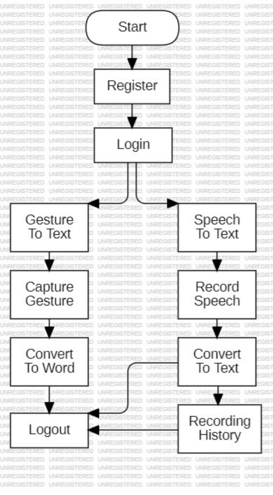

The real-time inference module utilizes the trained MobileNet model to classify hand gestures from live camera input, providing instantaneous results. The speech recognition module ensures seamless transcription, enabling multimodal accessibility. A user-friendly interface is designed to display recognized text output from both gesture and speech inputs. A robust backend, potentially implemented using Flask, handles user interactions, processes real-time inputs, and manages data for performance tracking.

Overall, the software design seamlessly integrates MobileNet-based deep learning techniques and speech recognition, ensuring an efficient, real-time system for assisting individuals with speech and hearing impairments. Its lightweight architecture facilitates quick and accurate processing, making it suitable for deployment on mobile platforms or edge devices.

* 1. **Data flow diagrams (or) UML Diagrams:**

A use-case diagram in the Unified Modelling Language (UML) is a type of behavioral diagram defined by and created from a Use-case analysis. Its purpose is to present a graphical overview of the functionality provided by a system in terms of actors, their goals (represented as use cases), and any dependencies between those use cases.

The main purpose of a use case diagram is to show what system functions are performed for which actor. The roles of the actors in the system can be depicted. Interaction among actors is not shown on the use case diagram. If this interaction is essential to a coherent description of the desired behavior, perhaps the system or use case boundaries should be re-examined. Alternatively, interaction among actors can be part of the assumptions used in the use case.

The Primary goals in the design of the UML are as follows:

● Provide users with a ready-to-use, expressive visual modelling Language so that they can develop and exchange meaningful models.

● Provide extensibility and specialization mechanisms to extend the core concepts.

● Be independent of particular programming languages and development processes.

● Provide a formal basis for understanding the modelling language.

● Encourage the growth of the OO tools market.

● Support higher-level development concepts such as collaborations, frameworks, patterns, and components.

UML encompasses various diagram types, including class diagrams for illustrating classes and relationships, sequence diagrams for depicting interactions over time, and use case diagrams for outlining system functionalities. Widely adopted in the software development lifecycle, UML diagrams offer a visual means to document, analyze, and design systems, fostering a common understanding among developers, designers, and project stakeholders.

**1.UseCase Diagram:**

A Use Case Diagram is a visual representation of the interactions between actors

(external entities) and use cases (system functionalities) within a system. It serves

as a blueprint for understanding the functional requirements of a system from a

user's perspective.

Use Case Diagrams aid in communication between stakeholders by providing a

clear and concise overview of system functionalities and user interactions. They

guide the development process by outlining the various scenarios and interactions

that need to be implemented.

Actors are external entities that interact with the system. These can include users,

other systems, or hardware devices. In the context of a Use Case Diagram, actors

initiate use cases and receive the outcomes. Proper identification and understanding

of actors are crucial for accurately modeling system behavior.

Actors: Actors are external entities that interact with the system. They can represent

users, other systems, or hardware devices.

Use Cases: Use cases represent specific functionalities or tasks that the system can

perform. They are like scenes in a play, depicting actions or interactions between

actors and the system.

Relationships: Relationships in a Use Case Diagram depict the interactions between

actors and use cases. They provide a comprehensive view of the system's

functionality and its various scenarios.

* **System**:  
  Represents the entire gesture and audio recognition system. This encompasses the Flask-based web application that facilitates user authentication, gesture and audio input processing, prediction generation, result display, and recording history management. The System interacts with all major components involved in these processes, serving as the central hub that connects the user with the application's core functionalities.

download or delete records. It connects to AudioInput to store new entries and supports user interaction for historical data management.

* **User**:  
  Represents the end-users interacting with the system. The User initiates various use cases, including Register and Login for authentication, GestureInput and AudioInput for providing data, DisplayResults to view outcomes, and RecordHistory to manage past interactions. The User is the primary actor driving the system’s functionalities through the web interface.
* **Register:**  
  Describes the user action of creating a new account within the system. This use case initiates the process of collecting user details (e.g., name, email, password) and storing them in the MySQL database via the /register route. It connects to the Login use case, enabling new users to authenticate after registration.
* **Login**:  
  Encompasses the process of user authentication. Users provide their email and password through the /login route, which verifies credentials against the users table in the database. Upon successful login, the session is established, connecting to subsequent use cases like GestureInput, AudioInput, PredictResults, DisplayResults, and RecordHistory, allowing authenticated access to the system's features.
* **GestureInput**:  
  Represents the user action of providing gesture data, likely captured via the webcam through the /open_webcam route, which triggers the execution of live.py. This use case initiates the PredictResults process by sending gesture data to the system for real-time analysis using machine learning models (e.g., TensorFlow/Keras with cvzone). It connects the user to the gesture recognition pipeline.
* **AudioInput**:  
  Describes the user action of uploading an audio file for transcription, handled via the /mic route. This use case involves processing the uploaded file using the SpeechRecognition library and storing the transcript in the recordings table of the database. It connects to PredictResults for potential audio-based predictions and RecordHistory for storing the input data.
* **PredictResults**:  
  Encompasses the core functionality of generating predictions based on GestureInput and AudioInput. This use case relies on trained machine learning models (e.g., loaded via Keras or TensorFlow) to analyze gesture or audio data in real-time, producing classification or transcription results. It connects to DisplayResults to forward the outcomes for user visualization.
* **DisplayResults**:  
  Allows users to visualize the outcomes of the PredictResults use case. This process renders the prediction or transcription results (e.g., gesture labels or audio transcripts) in templates like prediction.html, providing feedback to the user. It connects to PredictResults to display the processed data accurately.
* **RecordHistory**:  
  Represents the functionality of viewing and managing the history of audio recordings and potentially gesture inputs. This use case retrieves data from the recordings table via the /my_recordings route and displays it in recordings.html, allowing users to who can then view the categorized outcomes, thus completing the activity loop. This diagram succinctly illustrates the dynamic progression of tasks within the garbage classification system, encapsulating user interactions, preprocessing, training, and real-time classification activities.

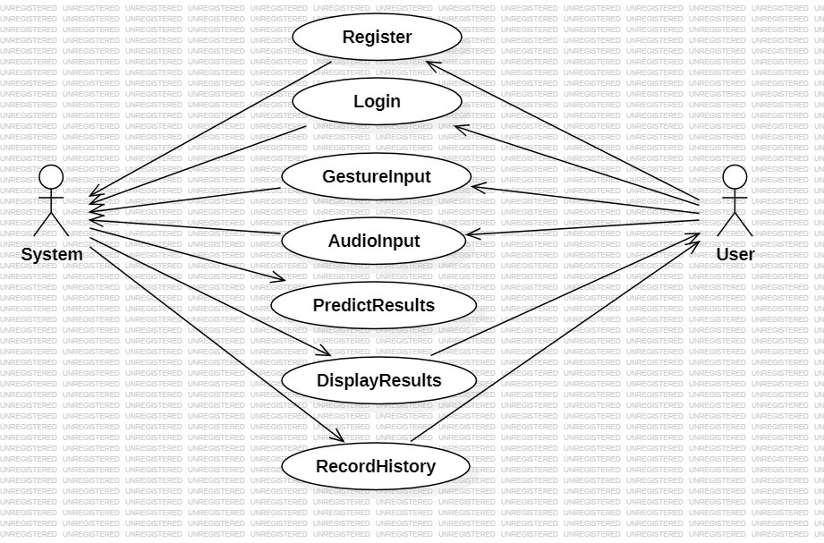

**2.Activity Diagram:**

Activity Diagrams are used to illustrate the flow of control in a system and refer to

the steps involved in the execution of a use case. It is a type of behavioral diagram

and we can depict both sequential processing and concurrent processing of activities

using an activity diagram i.e. an activity diagram focuses on the condition of flow and

the sequence in which it happens. Activity Diagrams provide a visual representation

of the dynamic aspects of a system, focusing on the flow and sequence of activities.

They help stakeholders understand the order in which activities are performed and

how control flows between them.

Activity Diagrams can depict both sequential processing and concurrent processing

of activities. Sequential processing refers to activities that are performed one after

the other in a linear sequence. Concurrent processing refers to activities that can be

performed simultaneously or in parallel. Activity Diagrams primarily focus on the

condition of flow and the sequence in which activities happen. They use symbols such

as nodes, edges, and swim lanes to represent activities, decisions, and concurrency.

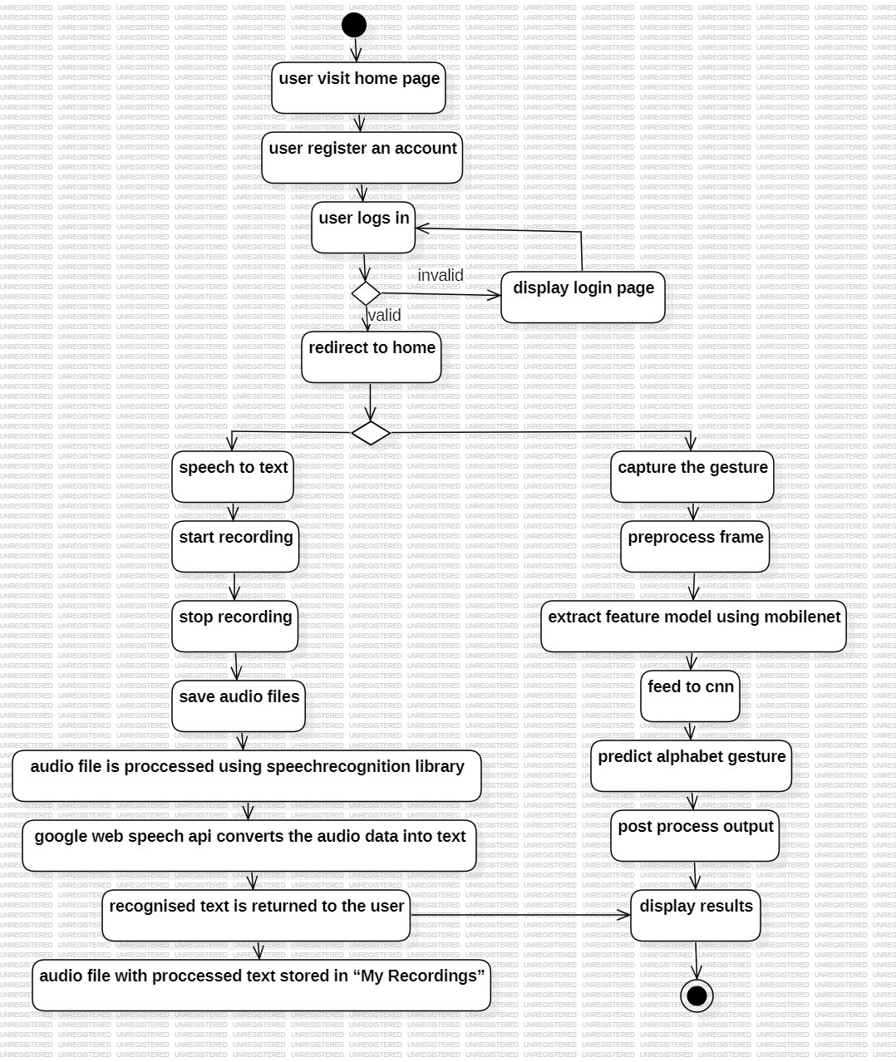

The activity diagram for our project illustrates the sequential flow of activities involved in user registration, login, speech-to-text conversion, and gesture recognition processes on the website. The process begins with the actor (user) initiating the "user visit home page" activity. This leads to the "user register an account" activity, where the user provides necessary details to create an account. Upon successful registration, the user proceeds to the "user logs in" activity.

The login process involves the user entering their credentials, which the system validates. If the credentials are invalid, the system displays the login page again, allowing the user to retry. Upon successful validation, the user is redirected to the home page. From there, the diagram branches into two parallel processes: "speech to text" and "capture the gesture."

The "speech to text" process starts with the "start recording" activity, followed by "stop recording" and "save audio files." The audio file is then processed using a speech recognition library. Specifically, the Google Web Speech API converts the audio data into text. The recognized text is returned to the user, and the audio file with the processed text is stored in "My Recordings."

Simultaneously, the "capture the gesture" process begins with the "preprocess frame" activity, followed by "extract feature model using MobileNet." The extracted features are then fed to a CNN (Convolutional Neural Network) to "predict alphabet gesture." The output is post-processed and the results are displayed to the user.

Throughout these activities, the system ensures a seamless flow between user interactions and the underlying processing mechanisms. The activity diagram provides a visual representation of the entire workflow, highlighting the integration of speech-to-text conversion and gesture recognition functionalities, along with error handling for invalid login attempts, ensuring a robust user experience.

**3.Sequence Diagram:**

Sequence Diagrams depict the interaction between objects in a system in a

sequential order, illustrating the order in which these interactions occur. They are

also referred to as event diagrams or event scenarios. Sequence Diagrams describe

how and in what order the objects in a system function. They are widely used by

businessmen and software developers to document and understand requirements for new and existing systems. They provide a clear and concise representation of the

sequence of events that occur during the execution of a use case or scenario.

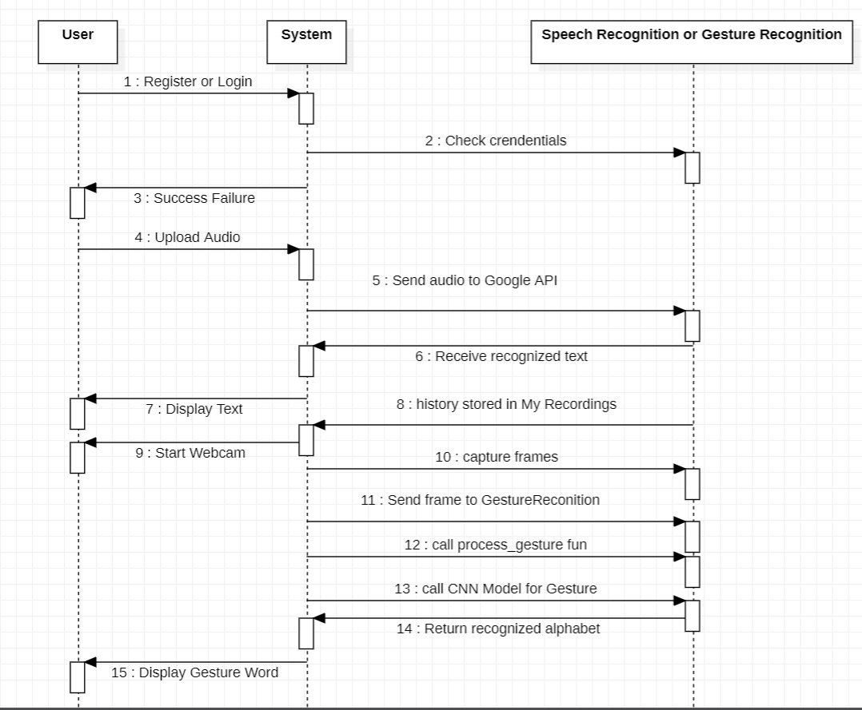

The sequence diagram for our project’s user registration, login, speech-to-text conversion, and gesture recognition processes illustrates the chronological order of interactions among the key actors: User, System, and Speech Recognition or Gesture Recognition modules.

The sequence begins with the User triggering the "Register or Login" message, prompting the System to collect and validate the user's credentials. The System performs a "Check credentials" action internally to verify the input. If successful, the System sends a "Success Failure" message back to the User, confirming whether the registration or login attempt was successful. Upon successful authentication, the User gains access to the system's functionalities.

Following a successful login, the User initiates the "Upload Audio" message to start the speech-to-text process. The System communicates with the Speech Recognition module by sending a "Send audio to Google API" message. The Speech Recognition module processes the audio and returns a "Receive recognized text" message to the System. The System then stores the audio and its corresponding text with the "history stored in My Recordings" action and sends a "Display Text" message to the User, presenting the recognized text for review.

In parallel, the User triggers the gesture recognition process by sending a "Start Webcam" message to the System. The System responds by initiating a "capture frames" action to collect gesture data from the webcam. The System then communicates with the Gesture Recognition module by sending a "Send frame to GestureRecognition" message. The Gesture Recognition module processes the frame with a "call process_gesture fun" action and further utilizes a "call CNN Model for Gesture" to predict the gesture. The module returns a "Return recognized alphabet" message to the System, which then sends a "Display Gesture Word" message to the User, presenting the recognized gesture in the form of an alphabet or word.

Throughout these interactions, the sequence diagram emphasizes the dynamic flow of messages between the User, System, and Speech Recognition or Gesture Recognition modules, providing a detailed representation of the processes involved in registration, login, speech-to-text conversion, and gesture recognition functionalities on the website. The diagram ensures clarity in how audio and gesture inputs are processed and how results are communicated back to the user, highlighting the integration of external APIs (Google Web Speech API) and machine learning models (CNN via MobileNet) in the system’s workflow.

**4.Class Diagram:**

Class diagrams are a type of UML (Unified Modeling Language) diagram used in

software engineering to visually represent the structure and relationships of classes

within a system i.e. used to construct and visualize object-oriented systems. Class

diagrams provide a high-level overview of a system’s design, helping to communicate

and document the structure of the software. They are a fundamental tool in object

oriented design and play a crucial role in the software development lifecycle.

.

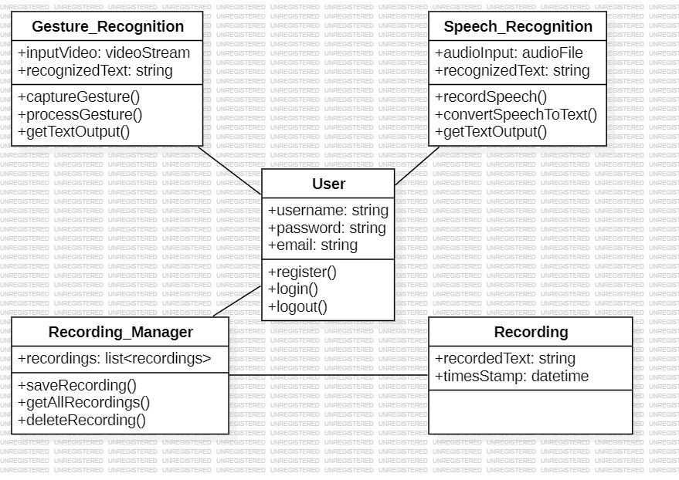

The class diagram for our project incorporates the specific requirements and attributes for each component involved in user management, speech recognition, gesture recognition, and recording management, along with their interactions and relationships.

Starting with the "User" class, it includes attributes such as "username," "password," and "email," all of type string, to store user credentials and contact information. The "password" attribute is marked as private to enhance security. Public methods like "register()," "login()," and "logout()" are included, reflecting the actions a user can perform to interact with the system. The "User" class serves as the central entity interacting with other components.

The "Speech_Recognition" class contains attributes like "audioInput" of type audioFile and "recognizedText" of type string to handle audio data and its converted text output. Public methods such as "recordSpeech()," "convertSpeechToText()," and "getTextOutput()" are included to represent the process of recording audio, converting it to text using an API (e.g., Google Web Speech API), and retrieving the result. The "User" class interacts with the "Speech_Recognition" class through a one-to-one relationship, indicating that each user can perform speech recognition tasks.

Similarly, the "Gesture_Recognition" class includes attributes like "inputVideo" of type videoStream and "recognizedText" of type string to manage video input and the recognized gesture output. Public methods such as "captureGesture()," "processGesture()," and "getTextOutput()" are present to capture video frames, process them using a CNN model (e.g., MobileNet), and return the recognized gesture in text form. The "User" class also interacts with the "Gesture_Recognition" class through a one-to-one relationship, signifying that each user can perform gesture recognition tasks.

The "Recording" class contains attributes like "recordedText" of type string and "timeStamp" of type datetime to store the recognized text and the time of recording. This class is associated with the "Speech_Recognition" class, as it stores the output of the speech-to-text process. The "Recording" class interacts with the "Recording_Manager" class through a one-to-many relationship, indicating that one recording manager can manage multiple recordings.

The "Recording_Manager" class includes an attribute "recordings" of type list<recordings> to manage a collection of recordings. Public methods like "saveRecording()," "getALLRecordings()," and "deleteRecording()" are included to handle the storage, retrieval, and deletion of recordings. The multiplicity between "Recording_Manager" and "Recording" is 1 to 1..., signifying that one recording manager can handle multiple recording entries.

The class diagram effectively captures the structure of your project, highlighting the attributes and methods of each component while emphasizing the relationships between the classes. This visual representation serves as a valuable guide for developers, providing a clear blueprint for implementing the necessary functionalities for user management, speech and gesture recognition, and recording management, ensuring a seamless and efficient system

**5.System Implementation**

**5.1 Introduction:**

System implementation is a critical phase in the development lifecycle of any project, involving the actual construction and deployment of the system based on the requirements and design specifications. This phase encompasses translating the conceptual designs and plans into tangible, functioning software or hardware systems that meet the intended objectives. System implementation involves several key steps and considerations to ensure a successful transition from development to operational use.

The first step in system implementation is to prepare the infrastructure and environment necessary for deploying the system. This includes setting up the hardware, software, and networking components required to support the system's operation. It may involve procuring and configuring servers, databases, networking equipment, and other resources essential for hosting and running the system. Adequate testing and validation of the infrastructure are crucial to ensure that it can effectively support the system's requirements in terms of performance, scalability, and reliability.

Once the infrastructure is in place, the next step is to deploy the system components according to the design specifications. This involves installing and configuring the software modules, integrating various subsystems, and establishing communication channels between different components. The deployment process may vary depending on the nature of the system, whether it is a standalone application, a distributed system, or a cloud-based service. Careful attention must be paid to ensure that the deployment process is smooth and error free, minimizing disruptions to existing operations.

During the implementation phase, rigorous testing is conducted to validate the functionality, performance, and reliability of the system. This includes unit testing, integration testing, system testing, and acceptance testing to verify that the system meets the specified requirements and performs as expected. Testing may involve simulating real-world scenarios, stress testing the system under heavy loads, and evaluating its resilience to failures and errors. Any issues or defects identified during testing must be promptly addressed and resolved to ensure the quality and stability of the system. In addition to technical considerations, system implementation also involves preparing the end-users and stakeholders for the adoption of the new system.

This includes providing training and support to help users understand how to use the system effectively and efficiently. User documentation, manuals, and tutorials may be developed to assist users in familiarizing themselves with the system's features and functionalities. Communication and change management strategies are essential to manage expectations, address concerns, and foster a smooth transition to the new system.

In summary, system implementation is a complex and multifaceted process that involves preparing the infrastructure, deploying the system components, testing functionality, and preparing users for adoption. It requires careful planning, coordination, and collaboration between various stakeholders to ensure a successful transition from development to operational use. By following best practices and leveraging appropriate tools and methodologies, organizations can effectively implement systems that meet their objectives and deliver value to their users.

**5.1.1 Data Selection:**

In selecting data for gesture-to-text conversion using MobileNet and deep learning techniques, several factors are considered. The ASL dataset is used to train the model to recognize various hand gestures corresponding to different alphabets. The dataset includes diverse images covering different angles, lighting conditions, and hand positions to ensure the model learns to classify gestures effectively in real-world scenarios.

Each image in the dataset is accurately labeled with the corresponding letter, allowing the model to associate visual features with specific gestures. Proper labeling is crucial for the deep learning model to correctly map hand movements to textual output.

To ensure fairness and robustness, the dataset is curated to maintain a balanced representation of different hand gestures. This helps prevent bias toward certain signs and ensures accurate recognition across all included gestures.

For the speech-to-text module, we directly integrate the Google Web Speech API, eliminating the need for a separate dataset. This API processes spoken language and transcribes it into text in real time, providing a seamless experience for users.

**5.1.2** **Data preprocessing:**

Data preprocessing is a crucial step in developing an efficient deep learning model for real-time dual-feature system using hand gestures. Since this project utilizes a CNN-based approach for American Sign Language (ASL) recognition, preprocessing the dataset ensures optimal performance and accuracy of the model. The dataset consists of images of hand gestures representing different ASL alphabets, which may vary in resolution, lighting conditions, background noise, and orientation, all of which can impact model performance. To standardize the input data, images are resized to a fixed dimension (1024x1024) to maintain consistency and compatibility with the CNN model. Depending on the model requirements, images are converted to grayscale to reduce complexity. Additionally, pixel values are normalized to a range of [0,1] to improve convergence speed during training.

To enhance the dataset’s diversity and prevent overfitting, various data augmentation techniques are applied, including random rotations, horizontal and vertical flipping to simulate variations in hand orientations, brightness and contrast adjustments to improve robustness against different lighting conditions, and random cropping and zooming to help the model generalize better to real-world scenarios. The preprocessed dataset is then split into two subsets: the training set, which is used to train the CNN model and comprises approximately 90% of the data and the test set, which is used to evaluate the model on unseen data 10%.

Since each ASL gesture corresponds to a specific letter, class labels are converted into a suitable format using one-hot encoding, where each gesture class is represented as a one-hot vector for categorical encoding, which is used for models requiring numerical class labels. We employ **Global Average Pooling (GAP)** to reduce spatial dimensions while retaining essential feature information. GAP helps prevent overfitting by reducing the number of trainable parameters and ensuring better generalization, making it an effective alternative for handling variations in gesture data.

For the speech-to-text component, we do not perform any preprocessing such as noise reduction, spectrogram conversion, or tokenization. Instead, we leverage the **Google Web Speech API** and the **SpeechRecognition** library to directly convert speech into text. These tools handle the entire speech processing pipeline, ensuring accurate and efficient recognition without requiring additional preprocessing steps. By focusing on efficient data handling and model optimization, the system remains robust and effective in real-time assistive communication.

**5.1.3 Model Selection:**

In selecting a model for gesture-to-text conversion using MobileNet and deep learning techniques like CNN, several factors are considered. MobileNet is chosen for its efficiency and lightweight architecture, making it well-suited for real-time applications with limited computational resources. Since the system needs to accurately recognize ASL (American Sign Language) gestures, the model should be robust to variations in hand position, lighting conditions, and background clutter.

Additionally, a CNN-based model is used alongside MobileNet to enhance feature extraction and classification accuracy. The CNN model is trained specifically on ASL dataset images, enabling better adaptation to sign language recognition. The training process ensures that the model learns meaningful representations of gestures, improving its ability to classify hand movements effectively.

For the speech-to-text module, google-web-speech API along with SpeechRecognition library is used due to its high accuracy in transcribing spoken words into text. This approach eliminates the need for heavy computational models while ensuring reliable speech processing.

Considering real-world constraints such as latency, computational efficiency, and accuracy, MobileNet’s balance between performance and lightweight deployment makes it an optimal choice for gesture recognition. Similarly, leveraging pre-trained speech-to-text APIs ensures seamless and efficient speech processing. Together, these models create a robust and accessible communication system for individuals with hearing and speech impairments.

**5.1.4 Model Transfer**:

In the realm of gesture-to-text conversion using MobileNet and deep learning technique like CNN, transfer learning plays a crucial role. Transfer learning involves leveraging knowledge gained from one task or domain and applying it to another. Instead of training MobileNet from scratch, a pre-trained MobileNet model, which has already learned to recognize general image features from a vast dataset is used as a feature extractor for gesture recognition.

The pre-trained MobileNet model's feature extraction capabilities are then fine-tuned or adapted to recognize ASL (American Sign Language) gestures. This fine-tuning process saves significant training time and computational resources while enhancing the model’s ability to differentiate between various hand signs. By training the model with a dataset of ASL images, MobileNet learns to recognize gesture-specific patterns effectively. The extracted features are then fed into a custom CNN classifier, which refines the predictions and maps them to corresponding text outputs.

For the speech-to-text module, transfer learning is indirectly applied by utilizing google-web-speech API, which is trained on large-scale speech datasets. This eliminates the need for extensive training while ensuring high accuracy in real-world speech transcription.

Ultimately, transfer learning enables efficient adaptation of MobileNet for gesture recognition, ensuring high accuracy with limited labeled data. Similarly, leveraging pre-trained speech models streamlines speech-to-text conversion, creating a robust and resource-efficient communication system for individuals with hearing and speech impairments.

**5.1.5 Model Training:**

Model training for gesture-to-text conversion using MobileNet and CNN involves several steps to enable accurate recognition of hand gestures. Initially, a large dataset of American Sign Language (ASL) gestures is collected and labeled. These images serve as training samples for the model. During training, the pre-trained MobileNet model acts as a feature extractor, identifying key visual patterns in the gesture images. The extracted features are then passed through a custom CNN classifier, which maps them to corresponding text labels.

The training process involves multiple iterations, where the model adjusts its internal parameters to minimize the difference between predictions and actual labels. This optimization is achieved using techniques like Adam optimizer. Data augmentation (such as rotation, scaling, and flipping) may also be applied to improve the model’s ability to generalize to different hand positions and lighting conditions. Training continues until the model achieves a high accuracy in recognizing gestures.

For speech-to-text conversion, the system utilizes google-web-speech API, which is already trained on large-scale speech datasets. Instead of training a speech model from scratch, this API processes spoken input and converts it into text with high accuracy.

Once trained and integrated, the combined system allows for real-time recognition of both gestures and speech, facilitating a dual-feature system for individuals with hearing or speech impairments.

**5.1.6 Evaluation:**

Evaluation in the context of gesture-to-text and speech-to-text conversion involves assessing the model's accuracy, reliability, and effectiveness in real-world applications.

For the gesture-to-text module, the evaluation process includes testing the CNN-based model on a dataset of ASL gesture images. The model’s predictions are compared with the correct labels, and performance metrics such as accuracy, precision, recall, and F1-score are calculated. The system’s ability to correctly classify gestures under varying lighting conditions, backgrounds, and hand orientations is also assessed.

For the speech-to-text module, evaluation involves analyzing how accurately the model transcribes spoken words into text. This includes testing the system with different speakers, accents, speech speeds, and background noise levels. Metrics such as word error rate (WER) and phoneme error rate (PER) are used to measure transcription accuracy.

Additionally, cross-validation can be applied to ensure that the model generalizes well across different datasets. The final evaluation determines how well the system performs in real-world conditions, guiding potential improvements and optimizations for enhanced usability and robustness.

**5.1.7 Testing and Validation:**

In the context of gesture-to-text and speech-to-text conversion using deep learning and api, testing and validation are essential for evaluating the system’s accuracy, robustness, and real-world applicability.

Validation occurs during training, where a portion of the dataset is set aside to assess the model's learning progress. For the gesture-to-text module, this involves validating the CNN-based classifier using unseen ASL gesture images to ensure it generalizes well and does not overfit the training data. For the speech-to-text module, validation helps fine-tune the speech recognition system’s accuracy under different noise levels and accents which happens internally.

Testing is performed after training, using completely new data that the model has never seen before. In the gesture module, test images of hand signs are fed into the system to verify whether the model correctly translates them into corresponding words. In the speech module, spoken words from different users are processed by the google-web-speech API to evaluate transcription accuracy.

By systematically validating and testing both modules, the system's performance, accuracy, and robustness are measured, ensuring it can reliably assist individuals with speech or hearing impairments in real-world scenarios.

**5.1.8 Continuous improvement:**

Continuous improvement in the context of gesture-to-text and speech-to-text conversion involves refining the system over time to enhance its accuracy, adaptability, and user experience.

For the gesture-to-text module, improvements can be made by expanding the dataset to include a more diverse range of gestures, hand orientations, lighting conditions, and backgrounds. Fine-tuning the CNN model, using advanced architectures like Transformers or Vision-based models, and applying data augmentation techniques can further boost accuracy. Regular model retraining with newly collected gesture data ensures the system remains robust.

For the speech-to-text module, improvements involve incorporating more speech samples from diverse speakers, accents, and noisy environments. Enhancements in language models using techniques like transformer-based models (e.g., Whisper, Wav2Vec 2.0) can improve transcription accuracy. Additionally, fine-tuning the model based on real-time user feedback and incorporating error correction mechanisms can enhance performance.

By continuously evaluating and updating both modules with new data, optimizing model architectures, and leveraging real-world user interactions, the system becomes more accurate, responsive, and reliable in attaining a dual-feature system for individuals with hearing and speech impairments.

**5.2 Project Modules:**

This project consists of multiple modules that work together to enable real-time gesture and speech recognition into text conversion. Below is a detailed breakdown of the key modules:

**1. Data Collection and Preprocessing**

The gesture dataset consists of American Sign Language (ASL) images representing different hand gestures. To enhance model performance, the dataset ensures diversity by including variations in lighting conditions, hand orientations, and backgrounds. Additionally, data augmentation techniques such as rotation, scaling, and flipping are applied to improve generalization and robustness. For the speech-to-text module, instead of using a pre-collected speech dataset, the system integrates the Google-Web-Speech API for real-time speech recognition. This eliminates the need for extensive preprocessing, as the API handles noise reduction and normalizes input audio for improved accuracy in speech-to-text conversion.

**2. Gesture Recognition Module**

A pre-trained MobileNet model is utilized as a feature extractor by removing its top classification layers and fine-tuning it specifically for ASL gesture recognition. This allows the model to extract relevant features from input hand gesture images, which are then used for further classification. On top of these extracted features, a custom CNN-based classifier is designed to recognize different ASL gestures and map them to corresponding alphabets. The model is trained to improve recognition accuracy, and optimization techniques such as dropout and batch normalization are applied to enhance its performance and generalization.

**3. Speech-to-Text Module**

For real-time speech-to-text conversion, the SpeechRecognition library is first used to capture speech input from the user through a microphone while applying initial noise reduction to enhance clarity. The processed audio is then sent to the Google Web Speech API, which performs additional noise reduction and speech processing to improve recognition accuracy. Finally, the API converts the spoken words into text output with good precision. To further refine the results, text correction techniques are applied, ensuring improved transcription accuracy and overall system efficiency.

**4. User Interface (UI) Module:**

The User Interface (UI) Module is designed to provide a seamless and interactive experience for users. The frontend development focuses on creating a simple yet effective graphical user interface (GUI) to display recognized gestures and speech outputs in real-time. Frameworks like Flask are utilized for UI implementation, ensuring accessibility and ease of use. Additionally, a **"**My Recordings" tab is included to store previously recognized gestures and speech inputs along with their corresponding text. This feature allows users to review and manage enhancing usability and accessibility.

**5.3 Algorithm:**

In the project "A Dual-Feature System: Gesture-to-Word Using CNN and Speech-to-Text Conversion," deep learning techniques play a crucial role in enabling accurate and efficient gesture recognition. The system is designed as a user-friendly interface that includes two primary modules: Gesture-to-Word using Convolutional Neural Networks (CNNs) and Speech-to-Text Conversion using the Google Web Speech API. These two modules work independently to provide a dual-feature system for individuals with speech and hearing impairments.

The process begins with the Gesture-to-Word Module, where transfer learning with MobileNet as feature extractor is used and Convolutional Neural Networks (CNNs) are employed to recognize American Sign Language (ASL) gestures and convert them into meaningful words. Initially, a diverse dataset containing images of hand gestures representing all alphabets is collected. These images serve as input data for training the CNN model to distinguish between different gestures. To ensure robustness, preprocessing techniques such as image resizing, normalization, and grayscale conversion are applied. Additionally, data augmentation methods like rotation, flipping, and scaling help improve model generalization by introducing variations in the dataset.

During training, the CNN model undergoes an iterative learning process, where it extracts key features from the input images using convolutional, pooling, and activation layers. The convolutional layers detect patterns such as edges and shapes in hand gestures, while pooling layers reduce dimensionality, making the model more efficient. The final classification layer employs the softmax activation function to determine the most probable word corresponding to a given hand gesture. The training process involves optimization techniques like Adam optimizer and cross-entropy loss minimization to enhance model accuracy. Once trained, the model can recognize live gestures through a webcam, predict the corresponding letter, and display it on the screen as a word.

In parallel, the Speech-to-Text Module facilitates real-time transcription of spoken language into text. The process begins with capturing speech input through a microphone. To enhance speech clarity, background noise reduction techniques are applied. Once the audio is recorded, it undergoes feature extraction, where the SpeechRecognition library processes the input and utilizes the Google Web Speech API to transcribe the spoken words into text. The model identifies phonetic patterns and converts the speech into a structured textual format.

After transcription, post-processing techniques are applied to format the text for readability and accuracy. Context-based word prediction helps in correcting minor transcription errors. The final output is displayed on the user interface, allowing individuals to read the transcribed speech. This module ensures that a person with a hearing impairment can understand spoken words effectively.

The integration of these two modules provides a dual-feature system that benefits individuals with speech and hearing impairments. A deaf person can use the speech-to-text module to understand spoken words, while a mute person can use the gesture-to-word module to convey messages to non-sign language users. The system is designed for real-world usability, allowing both modules to function independently or in combination, depending on the user's needs.

Continuous improvement plays a crucial role in enhancing the system's performance over time. The gesture recognition model can be retrained with new data to improve accuracy under different lighting conditions and hand orientations. Similarly, the speech recognition module can be fine-tuned based on user feedback to enhance its ability to understand various accents and speech patterns. By continuously refining both modules, the system becomes more effective, reliable, and adaptable for real-world applications.

By leveraging deep learning techniques such as CNNs, transfer learning, and speech recognition models, the project aims to provide a dual-feature system for individuals with speech and hearing disabilities. Through rigorous model evaluation and optimization, the system provides an inclusive and efficient solution for effective communication.

**Architecture:**

In this project the architecture consists of two distinct yet interconnected modules: Gesture-to-Word using CNN and Speech-to-Text Conversion using the Google-Web-Speech API. This dual-feature system is designed to facilitate seamless connection for individuals with speech and hearing impairments by enabling both visual and auditory input processing.

The Gesture-to-Word Module is powered by a Convolutional Neural Network (CNN), which is specifically designed to recognize and classify American Sign Language (ASL) gestures. The CNN architecture is chosen due to its effectiveness in feature extraction from images and its ability to generalize across different hand orientations and lighting conditions. The model comprises multiple convolutional layers followed by activation functions, pooling layers, and fully connected layers. The convolutional layers are responsible for extracting spatial features such as edges, shapes, and patterns in hand gestures, while pooling layers reduce dimensionality, ensuring computational efficiency. The final classification layer utilizes a softmax activation function to determine the most probable word corresponding to a recognized gesture.

To improve the model’s generalization, transfer learning is employed using pre-trained CNN architectures such as MobileNet. These models, trained on large-scale image datasets, provide robust feature extraction capabilities that are fine-tuned for gesture recognition. Data augmentation techniques such as rotation, flipping, and contrast adjustments are applied to improve the model's robustness and adaptability to diverse hand gestures. The trained model is deployed for real-time recognition, where a webcam captures the user’s hand gestures, processes the image through the CNN model, and outputs the corresponding text.

The Speech-to-Text Module leverages automatic speech recognition (ASR) technology to transcribe spoken language into text. The architecture of this module is built around the Google-Web-Speech API, which provides powerful speech recognition capabilities with support for multiple languages and accents. The process begins with capturing audio input from a microphone, followed by preprocessing techniques such as noise reduction and feature extraction. The speech signal is then processed by the Google-Web-Speech API, which converts it into a structured textual format.

This module is optimized to work in real-time, allowing individuals with hearing impairments to instantly view the spoken words on their screen.

The integration of both modules provides a versatile dual-feature system that enhances accessibility for individuals with disabilities. A mute person can use the gesture-to-word module to convey messages to non-sign language users, while a deaf person can rely on the speech-to-text module to understand spoken words. The architecture is designed to function independently or in combination, allowing users to switch between modules based on their needs.

One of the key advantages of this architecture is its real-time processing capability. The gesture recognition model is optimized for low-latency predictions, enabling smooth interactions, while the speech-to-text module processes spoken language efficiently through cloud-based APIs.

In summary, the architecture of "A Dual-Feature System: Gesture-to-Word Using CNN and Speech-to-Text Conversion" combines deep learning-based visual recognition and speech processing technologies to create an inclusive communication platform. By leveraging CNNs for gesture recognition and ASR for speech transcription, the project provides an effective, and user-friendly solution that connects individuals with speech and hearing impairments. Through continuous improvements in model accuracy, data augmentation, and system integration, this architecture contributes to advancing assistive technologies and promoting accessibility.

**5.4 Screens:**

**Screen 1: Home Page (Landing Screen)**

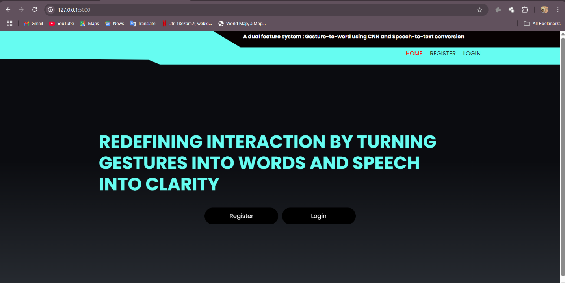

Description:

This screen serves as the landing page for a web application focused on gesture-to-word and speech-to-text conversion. The background is predominantly black, creating a sleek and modern aesthetic. At the top, a light cyan header bar spans the width of the screen, displaying a tagline in white text: "A dual feature system: Gesture-to-word using CNN and Speech-to-text conversion." This tagline highlights the core functionalities of the project, indicating that it leverages Convolutional Neural Networks (CNN) for gesture recognition and provides speech-to-text conversion capabilities.

Below the tagline, three navigation links are aligned on the right side of the header in red text: "HOME," "REGISTER," and "LOGIN." The "HOME" link is likely active, as this is the landing page, while "REGISTER" and "LOGIN" provide options for users to create an account or sign in.

The main content of the screen features a bold, large headline in white text with a cyan accent: "REDEFINING INTERACTION BY TURNING GESTURES INTO WORDS AND SPEECH INTO CLARITY." This headline is centered on the screen, drawing immediate attention to the project's purpose.

Beneath the headline, two prominent buttons are displayed side by side: "Register" on the left and "Login" on the right. Both buttons are black with white text, maintaining a minimalist design that aligns with the overall theme. These buttons likely redirect users to the registration and login pages, respectively, encouraging user engagement with the system.

The browser tabs visible at the top suggest that this page is being viewed on a local server (IP address: 127.0.0.1:5000), indicating that the project is likely in a development or testing phase.

**Screen 2: Registration Page**

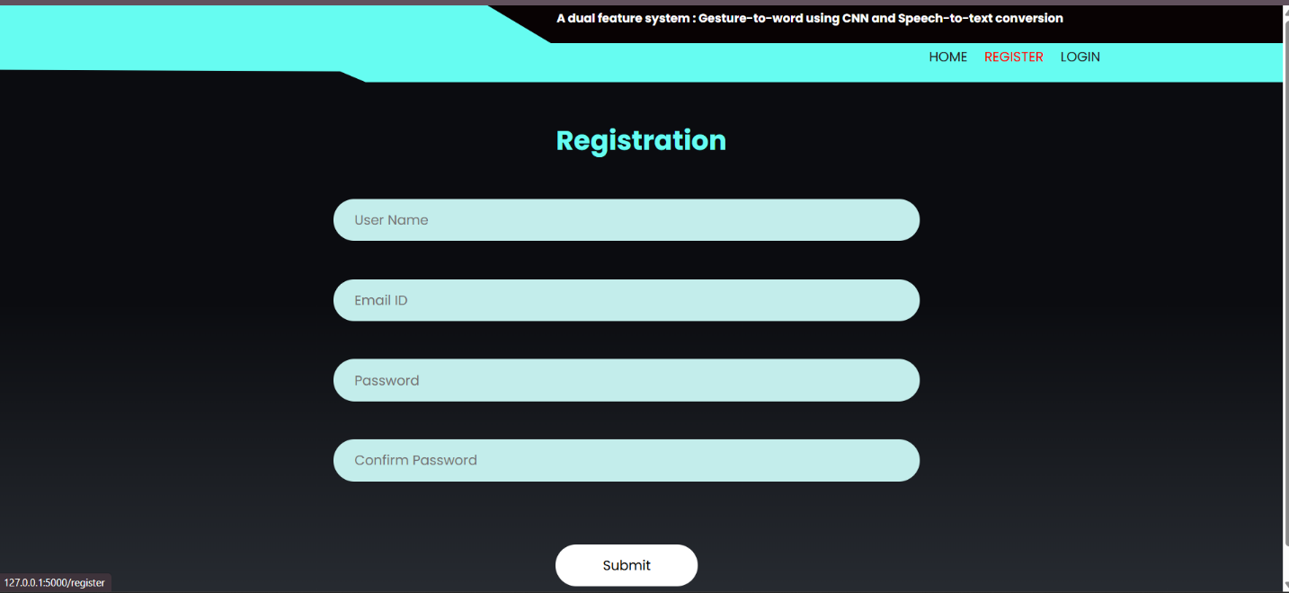

Description:

This screen represents the registration page of the web application, designed to allow new users to create an account.This reinforces the project's focus on gesture and speech recognition technologies. Three navigation links are displayed on the right side: "HOME," "REGISTER," and "LOGIN." The "REGISTER" link is likely active, as this is the registration page.

The main content is centered and begins with the word "Registration" in large, cyan text, serving as the page's title. Below the title, there is a simple form with four input fields, each enclosed in a light cyan, rounded rectangle with a placeholder label in gray text:

1. "User Name": A field for the user to enter their desired username.
2. "Email ID": A field for the user to input their email address.
3. "Password": A field for the user to enter a password.
4. "Confirm Password": A field to re-enter the password for verification.

Each input field is horizontally aligned and spaced evenly, creating a clean and user-friendly layout. Below the form, a prominent "Submit" button is centered, styled as a white, rounded rectangle with black text. This button allows users to submit their registration details once all fields are filled.

The URL at the top (127.0.0.1:5000/register) indicates that the page is hosted on a local server, suggesting that the project is in a development phase. The overall design is minimalistic, with a focus on functionality and ease of use, aligning with the project's technological theme.

**Screen 3: Login Page**

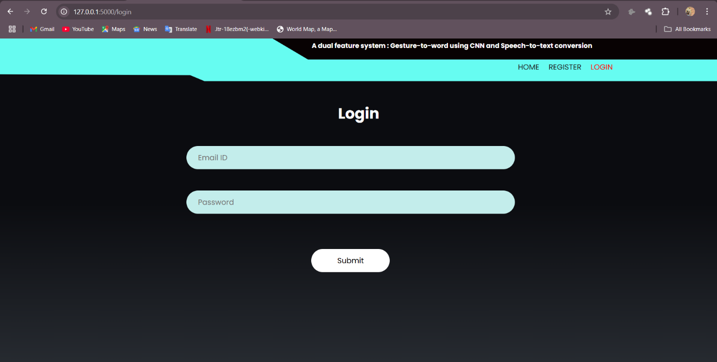

Description:

This screen is the login page of the web application, designed to allow existing users to access their accounts. Three navigation links are displayed on the right side: "HOME," "REGISTER," and "LOGIN." The "LOGIN" link is likely active, as this is the login page.

The main content is centered and begins with the word "Login" in large, white text, serving as the page's title. Below the title, there is a simple form with two input fields, each enclosed in a light cyan, rounded rectangle with a placeholder label in gray text:

1. "Email ID": A field for the user to enter their registered email address.
2. "Password": A field for the user to input their password.

Each input field is horizontally aligned and spaced evenly, ensuring a clean and user-friendly layout. Below the form, a prominent "Submit" button is centered. This button allows users to submit their login credentials to authenticate and access the application.

The URL at the top (127.0.0.1:5000/login) indicates that the page is hosted on a local server, suggesting that the project is in a development phase. The overall design is straightforward and functional, aligning with the project's technological theme and providing a seamless transition from the registration process to user authentication.

**Screen 4: About Page**

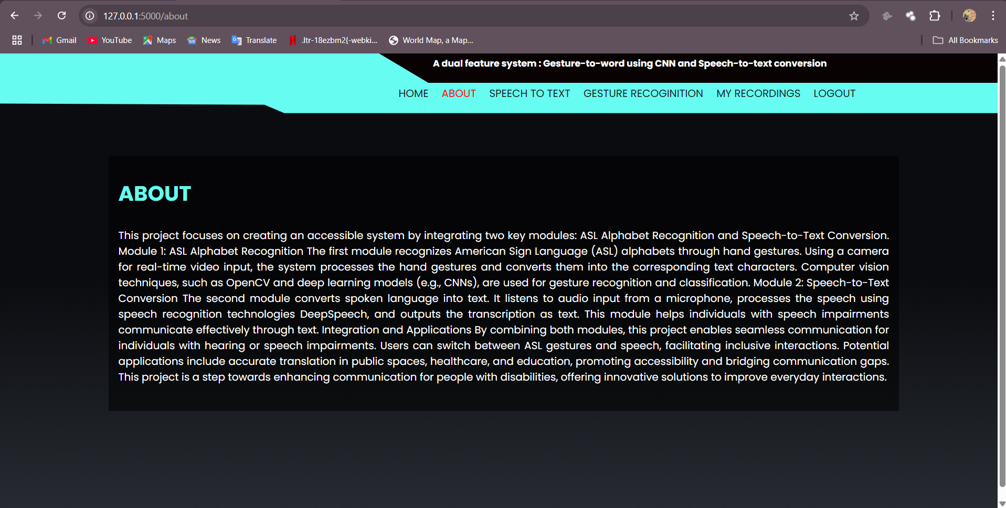

Description:

This screen is the "About" page of the web application, providing detailed information about the project's purpose and functionalities. A navigation menu with six links is aligned on the right side: "HOME," "ABOUT," "SPEECH TO TEXT," "GESTURE RECOGNITION," "MY RECORDINGS," and "LOGOUT." The "ABOUT" link is likely active, indicating that this is the current page, and the presence of "LOGOUT" suggests that the user is logged in.

The main content is centered and begins with the word "ABOUT" in large, bold, white text, serving as the page's title.

The text is presented within a slightly darker rectangular section, making it stand out against the black background while maintaining readability.

The URL at the top (127.0.0.1:5000/about) indicates that the page is hosted on a local server, suggesting that the project is in a development phase. The design remains clean and minimalistic, focusing on delivering information clearly and effectively.

**Screen 5: Speech to Text Page**

Description:

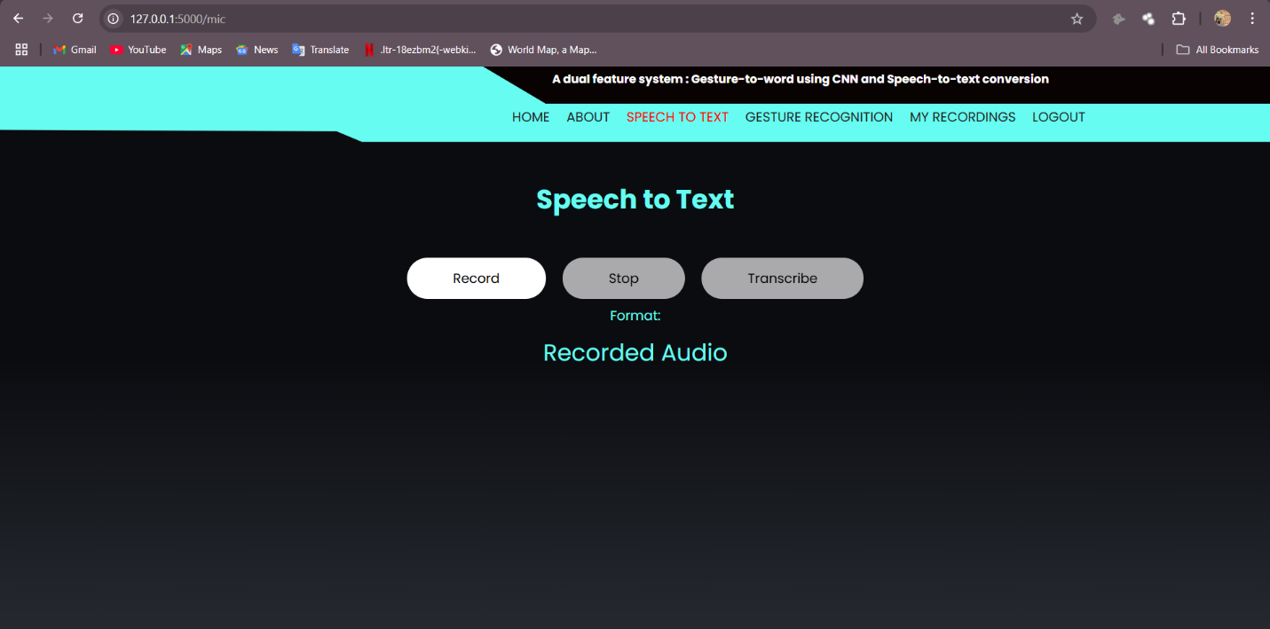

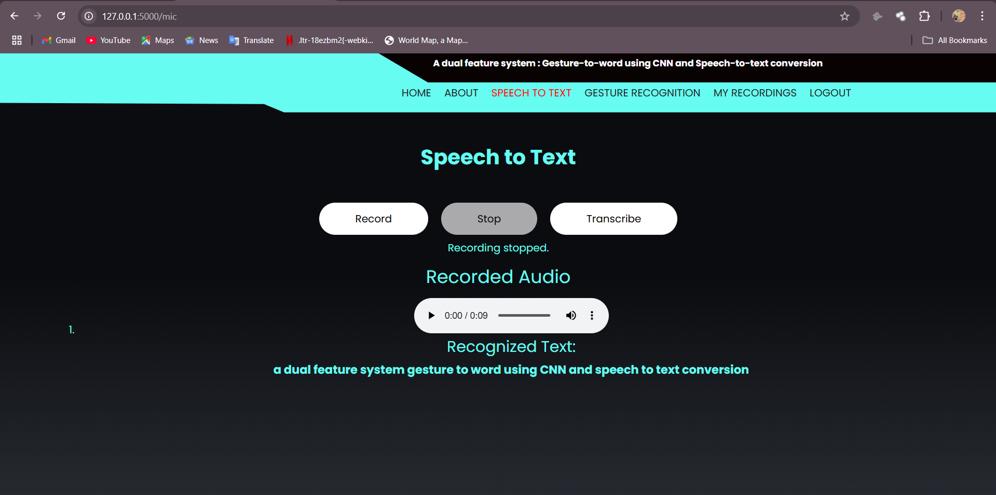

This screen is the "Speech to Text" page of the web application, designed to facilitate audio recording and transcription functionalities. A navigation menu with six links is aligned on the right side: "HOME," "ABOUT," "SPEECH TO TEXT," "GESTURE RECOGNITION," "MY RECORDINGS," and "LOGOUT." The "SPEECH TO TEXT" link is likely active, indicating that this is the current page, and the presence of "LOGOUT" suggests that the user is logged in.

The main content is centered and begins with the phrase "Speech to Text" in large, bold, white text, serving as the page's title. Below the title, there are three circular buttons labeled "Record," "Stop," and "Transcribe," arranged horizontally. The "Record" button is white, while the "Stop" and "Transcribe" buttons are gray, indicating that the recording has not yet started. Beneath these buttons, a section labeled "Recorded Audio" is displayed in white text, intended to show the recorded audio files or transcribed text once the process is initiated (shown in second figure),

The URL at the top (127.0.0.1:5000/mic) indicates that the page is hosted on a local server, suggesting that the project is in a development phase. The design is clean and minimalistic, focusing on functionality and user interaction for the speech-to-text feature.

**Screen 6: Sign Language Prediction Page**

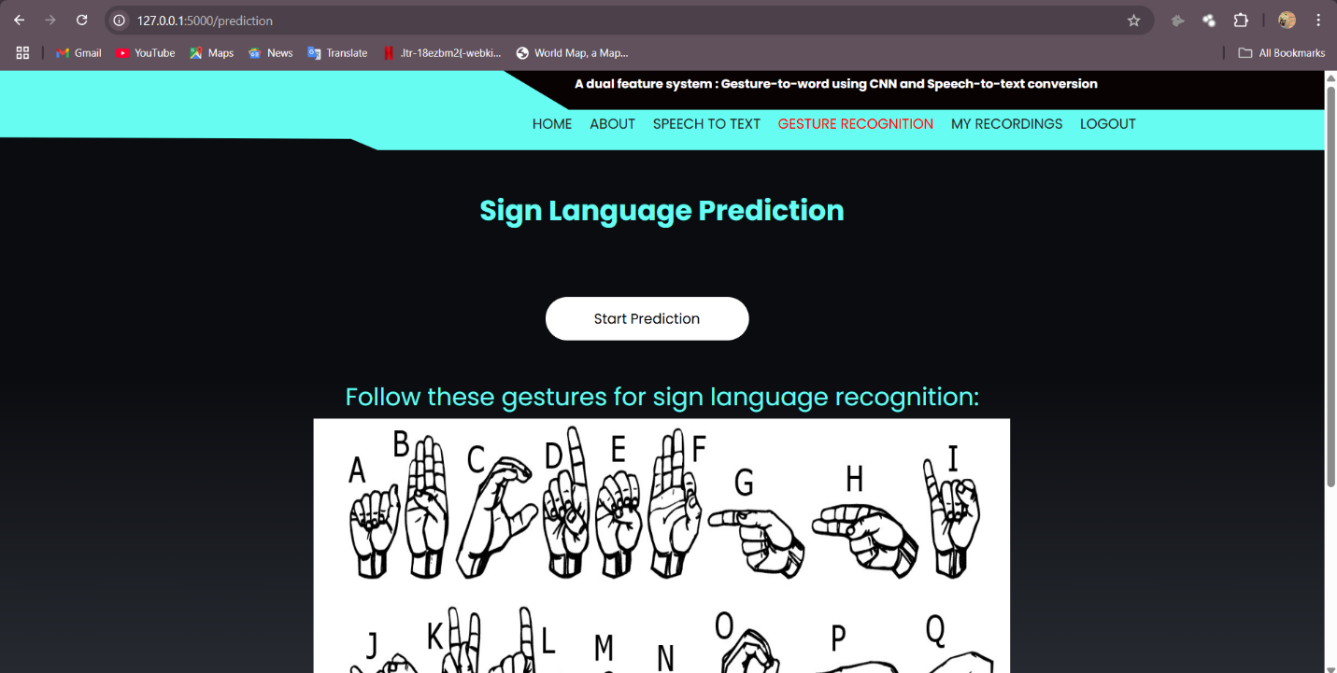

Description:

This screen is the "Sign Language Prediction" page of the web application, designed to facilitate gesture recognition for sign language interpretation. A navigation menu with six links is aligned on the right side: "HOME," "ABOUT," "SPEECH TO TEXT," "GESTURE RECOGNITION," "MY RECORDINGS," and "LOGOUT." The "GESTURE RECOGNITION" link is likely active, indicating that this is the current page, and the presence of "LOGOUT" suggests that the user is logged in.

The main content is centered and begins with the phrase "Sign Language Prediction" in large, bold, cyan text, serving as the page's title. Below the title, there is a single white circular button labeled "Start Prediction" in black text, which is likely used to initiate the gesture recognition process. Underneath the button, the text "Follow these gestures for sign language recognition:" is displayed in cyan, followed by a grid of hand gesture illustrations representing letters of the alphabet (A through Z). The gestures are depicted in black and white line drawings.

The URL at the top (127.0.0.1:5000/prediction) indicates that the page is hosted on a local server, suggesting that the project is in a development phase. The design is clean and minimalistic, focusing on guiding users through the sign language prediction process with clear visual instructions.

**Screen 7: Sign Language Detection Page**

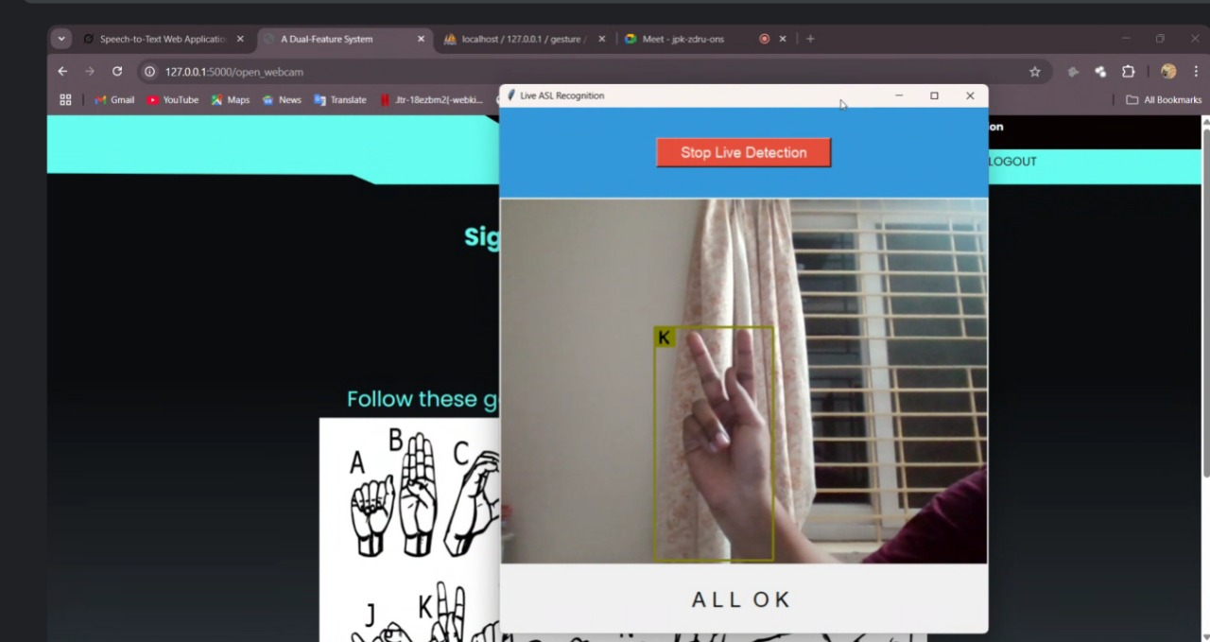

Description:

This screen is the "Sign Language Detection" page of the web application, designed to enable real-time gesture recognition for sign language interpretation using a webcam.

Below this, a live video feed from the webcam is displayed, showing a hand gesture (the letter "K" in sign language) within a green bounding box, indicating live detection for letter K, similarly other colours for other alphabets. A red button labelled "Stop Live Detection" is prominently placed in the center of the video feed, allowing the user to halt the detection process. Additionally, a white pop-up box at the bottom of the feed displays "ALL OK," likely indicating stacked letters from user sign detections.

The URL at the top (127.0.0.1:5000/open_webcam) indicates that the page is hosted on a local server, suggesting that the project is in a development phase. The design is clean and functional, focusing on real-time gesture detection with clear visual guidance and control options.

**Screen 8: My Speech-to-Text History Page**

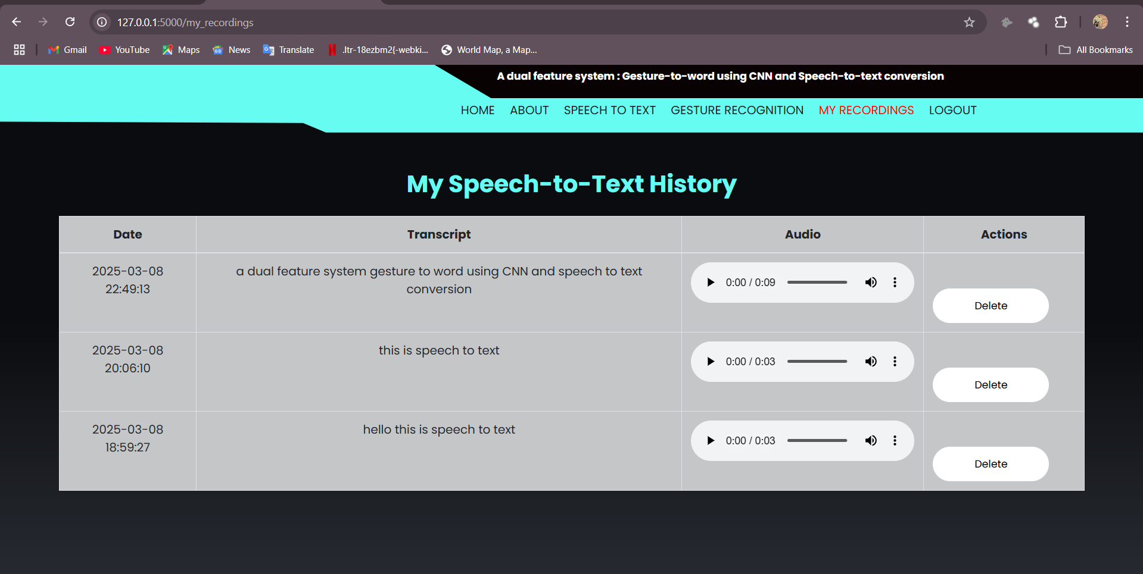

Description:

This screen is the "My Speech-to-Text History" page of the web application, designed to display a user's past speech-to-text recordings and their transcriptions. A navigation menu with six links is aligned on the right side: "HOME," "ABOUT," "SPEECH TO TEXT," "GESTURE RECOGNITION," "MY RECORDINGS," and "LOGOUT." The "MY RECORDINGS" link is likely active, indicating that this is the current page, and the presence of "LOGOUT" suggests that the user is logged in.

The main content is centered and begins with the phrase "My Speech-to-Text History" in large, bold, cyan text, serving as the page's title. Below the title, there is a table listing the user's recording history with four columns: "Date," "Transcript," "Audio," and "Actions."

The URL at the top (127.0.0.1:5000/my_recordings) indicates that the page is hosted on a local server, suggesting that the project is in a development phase. The design is clean and minimalistic, focusing on providing a clear and organized view of the user's speech-to-text history with options to review or delete recordings.

Additionally, we have logout button after the logout Home page will be displayed.

**6.System Testing**

**6.1 Introduction:**

Testing is the process of trying to discover every conceivable fault or weakness in a work product. It provides a way to check the functionality of components, subassemblies, assemblies and/or a finished product It is the process of exercising software with the intent of ensuring that the Software system meets its requirements and user expectations and does not fail in an unacceptable manner.

The purpose of testing is to discover errors. Testing is the process of trying to discover every conceivable fault or weakness in a work product. It provides a way to check the functionality of components, sub-assemblies, assemblies and/or a finished product It is the process of exercising software with the intent of ensuring that the Software system meets its requirements and userexpectations and does not fail in an unacceptable manner. There are various types of test. Each test type addresses a specific testing requirement.

There are various types of tests. Each test type addresses a specific testing requirement. Software Testing is evaluation of the software against requirements gathered from users and system specifications. Testing is conducted at the phase level in software development life cycle or at module level in program code. Software testing comprises of Validation and Verification.

Testing is a group of techniques to determine the correctness of the application under the predefined script but, testing cannot find all the defect of application. The main intent of testing is to detect failures of the application so that failures can be discovered and

corrected. It does not demonstrate that a product functions properly under all conditions but only that it is not working in some specific conditions.

Testing furnishes comparison that compares the behavior and state of software against mechanisms because the problem can be recognized by the mechanism. The mechanism may include past versions of the same specified product, comparable products, and interfaces of expected purpose, relevant standards, or other criteria but not limited up to these.

Testing includes an examination of code and also the execution of code in various environments, conditions as well as all the examining aspects of the code. In the current

scenario of software development, a testing team may be separate from the development team so that information derived from testing can be used to correct the process of software development**.**

System Testing is basically performed by a testing team that is independent of the development team that helps to test the quality of the system impartially.

Usually, software testing includes:

Unit tests: The program is broken down into blocks, and each element (unit) is tested separately.

Integration tests: This type of testing observes how multiple components of the program work together. Then, to evaluate the performance of the model in machine learning, we use two sets of data:

• Validation set: Having only a training set and a testing set is not enough. And that can result in overfitting. To avoid that, you can select a small validation data set to evaluate a model. Only after we get maximum accuracy on the validation set, we make the testing set come into the game.

• Test set: Our model might fit the training dataset perfectly well. But where are the guarantees that it will do equally well in real-life? In order to assure that, you select samples for a testing set from our training set, that the machine hasn’t seen before. It is important to remain unbiased during selection and draw samples at random. Also, we should not use the same set many times to avoid training on our test data. Our test set should be large enough to provide statistically meaningful results and be representative of the data set as a whole.

**Cross-validation:**

Cross-validation is a model evaluation technique that can be performed even on a limited dataset. The training set is divided into small subsets, and the model is trained and validated on each of these samples**.**

**Validation:**

In this method, we perform training on the 50% of the given data-set and rest 50% is used for the testingpurpose. The major drawback of this method is that we perform training on the 50% of the dataset, it may possible that the remaining 50% of the data contains some important information which we are leaving while training our model i.e higher bias.

**Leave One Out Cross Validation :**

In this method, we perform training on the whole data-set but leaves only one data-point of the available data-set and then iterates for each data-point. It has some advantages as well as disadvantages also. An advantage of using this method is that we make use of all data points and hence it is low bias. The major drawback of this method is that it leads to higher variation in the testing model as we are testing against one data point. If the data point is an outlier it can lead to higher variation. Another drawback is it takes a lot of execution time as it iterates over ‘the number of data points times.

**k-fold cross-validation:**

The most common cross-validation method is called k-fold cross-validation. To use it, you need to divide the dataset into k subsets (also called folds) and use them k times. For example, by breaking the dataset into 10 subsets, you will perform a 10-fold crossvalidation. Each subset must be used as the validation set at least once. In Machine Learning model development, the performance of the system is measured in terms of accuracy, precision and recall of the model. It's common to also use validation accuracy and test accuracy as evaluation metrics, which provide a better indication of the model's performance on unseen data.

**Accuracy:**

Accuracy is a metric for how much of the predictions the model makes are true. The higher the accuracy is, the better. However, it is not the only important metric when you estimate the performance.

Testing is the process of evaluating a system or its component(s) with the intent to find whether it satisfies the specified requirements or not. In simple words, testing is executing a system in order to identify any gaps, errors, or missing requirements in contrary to the actual requirements.

According to ANSI/IEEE 1059 standard, Testing can be defined as - A process of analysing a software item to detect the differences between existing and required conditions (that is defects/errors/bugs) and to evaluate the features of the software item.

It depends on the process and the associated stakeholders of the project(s). In the IT industry, large companies have a team with responsibilities to evaluate the developed software in context of the given requirements. Moreover, developers also conduct testing which is called Unit Testing. In most cases, the following professionals are involved in testing a system within their respective capacities –

• Software Tester

• Software Developer

• Project Lead/Manager

• End User

Different companies have different designations for people who test the software on the basis of their experience and knowledge such as Software Tester, Software Quality Assurance Engineer, QA Analyst, etc.

It is not possible to test the software at any time during its cycle. The next two sections state when testing should be started and when to end it during the SDLC.

An early start to testing reduces the cost and time to rework and produce error-free software that is delivered to the client. However in Software Development Life Cycle (SDLC), testing can be started from the Requirements Gathering phase and continued till the deployment of the software.

It also depends on the development model that is being used. For example, in the Waterfall model, formal testing is conducted in the testing phase; but in the incremental model, testing is performed at the end of every increment/iteration and the whole application is tested at the end.

In a software development project, errors can be introduced at any stage during development. Though errors are detected after each phase by techniques like inspections, some errors remain undetected.

Ultimately, these remaining errors are reflected in the code. There are two types of approaches for identifying defects in the software: static and dynamic. In static analysis, the code is not executed but is evaluated through some process or some tools for locating defects.

Code inspections, which we discussed in the previous chapter, are one static approach. Another is static analysis of code through the use of tools. In dynamic analysis, code is executed, and the execution is used for determining defects.

Testing is the most common dynamic technique that is employed. Indeed, testing is the most commonly used technique for detecting defects, and performs a very critical role for ensuring quality.

During testing, the software under test (SUT) is executed with a finite set of test cases, and the behavior of the system for these test cases is evaluated to determine if the system is performing as expected. The basic purpose of testing is to increase the confidence in the functioning of SUT.

Clearly, the effectiveness and efficiency of testing depends critically on the test cases selected.

Here we focus on:

Basic concepts and definitions relating to testing, like error, fault, failure, test case, test suite, test harness, etc.

• The testing process—how testing is planned and how testing of a unit is done.

• Test case selection using black-box testing approaches.

• Test case selection using white-box approaches.

• Some metrics like coverage and reliability that can be employed during testing.

The basic goal of the software development process is to produce software that has no errors or very few errors. We have seen that different levels of testing are needed to detect the defects injected during the various tasks in the project. The testing process for a project consists of three high-level tasks test planning, test case design, and test execution. We will discuss these in the rest of this section.

**1.Test Plan:**

In a project, testing commences with a test plan and terminates with successful execution of acceptance testing. A test plan is a general document for the entire project that defines the scope, approach to be taken, and the schedule of testing, as well as identifies the test items for testing and the personnel responsible for the different activities of testing.

The test planning can be done well before the actual testing commences and can be done in parallel with the coding and design activities.

The inputs for forming the test plan are:

(1) Project plan

(2) Requirements document

(3) Architecture or design document.

**2.Test Case Design:**

The test plan focuses on how the testing for the project will proceed, which units will be tested, and what approaches (and tools) are to be used during the various stages of testing. However, it does not deal with the details of testing a unit, nor does it specify which test cases are to be used.

**3.Test Case Execution:**

The test case specifications only specify the set of test cases for the unit to be tested. However, executing the test cases may require construction of driver modules or stubs. It may also require modules to set up the environment as stated in the test plan and test case specifications.

If test frameworks are being used, then the setting of the environment as well as inputs for a test case is already done in the test scripts, and execution is straightforward. During test case execution, defects are found.

**6.2 Testing methods :**

System Testing includes testing of a fully integrated software system.

Generally, a computer system is made with the integration of software (any software is only a single element of a computer system).

The software is developed in units and then interfaced with other software and hardware to create a complete computer system. In other words, a computer system consists of a group of software to perform the various tasks, but only software cannot perform the task; for that software must be interfaced with compatible hardware. System testing is a series of different types of tests with the purpose to exercise and examine the full working of an integrated software computer system against requirements.

To check the end-to-end flow of an application or the software as a user is known as System testing.

In this, we navigate (go through) all the necessary modules of an application and check if the end features or the end business works fine, and test the product as a whole system. It is end-to-end testing where the testing environment is similar to the production environment.

There are mainly two widely used methods for software testing, one is White box testing which uses internal coding to design test cases and another is black box testing which uses GUI or user perspective to develop test cases.

The following are the Testing Methodologies:

• Unit Testing.

• Integration Testing.

• Validation Testing.

• White box testing.

• Black box testing.

**Unit Testing :**

Unit testing focuses verification effort on the smallest unit of Software design that is the module. Unit testing exercises specific paths in a module’s control structure to ensure complete coverage and maximum error detection. This test focuses on each module individually, ensuring that it functions properly as a unit. Hence, the naming is Unit Testing. During this testing, each module is tested individually and the module interfacesare verified for the consistency with design specification. All important processing path are tested for the expected results. Unit Testing is a type of software testing where individual units or components of a software are tested. The purpose is to validate that each unit of the software code performs as expected. Unit Testing is done during the development (coding phase) of an application by the developers. Unit Tests isolate a section of code and verify its correctness. A unit may be an individual function, method, procedure, module, or object. In SDLC, STLC, V Model, Unit testing is first level of testing done before integration testing. Unit testing is a White Box testing technique that is usually performed by the developer. Though, in a practical world due to time crunch or reluctance of developers to tests, QA engineers also do unit testing.

• Unit tests help to fix bugs early in the development cycle and save costs.

• It helps the developers to understand the testing code base and enables them to make changes quickly.

• Good unit tests serve as project documentation

• Unit tests help with code re-use.

Migrate both your code and your tests to your new project. Tweak the code until the tests run again.

In order to execute Unit Tests, developers write a section of code to test a specific function in software application. Developers can also isolate this function to test more rigorously which reveals unnecessary dependencies between function being tested and other units so the dependencies can be eliminated. Developers generally use Unit Test framework to develop automated test cases for unit testing.

Unit Testing is of two types:

• Manual

• Automatic

Unit testing is commonly automated but may still be performed manually. Software Engineering does not favor one over the other but automation is preferred.

**Integration Testing :**

Integration testing addresses the issues associated with the dual problems of verificationand program construction. After the software has been integrated a set of high order tests are conducted. The main objective in this testing process is to take modules and builds a program structure that has been dictated by design. Integration Testing is defined as a type of testing where software modules are integrated logically and tested as a group. A typical software project consists of multiple software modules, coded by different programmers. The purpose of this level of testing is to expose defects in the interaction between these software modules when they are integrated. Integration Testing focuses on checking data communication amongst these modules. Hence it is also termed as ‘I&T’ (Integration and Testing), ‘String Testing’ and sometimes ‘Thread Testing’.

• A Module, in general, is designed by an individual software developer whose understanding and programming logic may differ from other programmers. Integration Testing becomes necessary to verify the software modules work in unity.

• At the time of module development, there are wide chances of change in requirements by the clients. These new requirements may not be unit tested and hence system integration Testing becomes necessary.

• Interfaces of the software modules with the database could be erroneous.

• External Hardware interfaces, if any, could be erroneous.

• Inadequate exception handling could cause issues.

Integration test case differs from other test cases in the sense it focuses mainly on the interfaces & flow of data/information between the modules. Here priority is to be given for the integrating links rather than the unit functions which are already tested.

Integration test approaches –

There are four types of integration testing approaches. Those approaches are the following:

• Big-Bang Integration Testing

• Bottom-Up Integration Testing

• Top-Down Integration Testing

• Mixed Integration Testing

**Big-Bang Integration Testing:**

It is the simplest integration testing approach, where all the modules are combining and verifying the functionality after the completion of individual module testing. In simple words, all the modules of the system are simply put together and tested. This approach is practicable only for very small systems. If once an error is found during the integration testing, it is very difficult to localize the error as the error may potentially belong to any of the modules being integrated. So, debugging errors reported during big bang integration testing is very expensive to fix. The Big-bang integration workflow diagram is a process diagram that shows how different parts of a system are integrated. It is typically used to show how different software components are integrated. It is a graphical representation of the software development process that is used in many organizations. It is a process that starts with the idea for a new software project and ends with the delivery of the software to the customer.

**Bottom-Up Integration Testing:**

Bottom-up Testing is a type of incremental integration testing approach in which testing is done by integrating or joining two or more modules by moving upward from bottom to top through control flow of architecture structure. In these, low-level modules are tested first, and then high-level modules are tested. This type of testing or approachis also known as inductive reasoning and is used as a synthesis synonym in many cases.Bottom-up testing is user-friendly testing and results in an increase in overall software development. This testing results in high success rates with long-lasting results.

**Processing :**

Following are the steps that are needed to be followed during the processing :

1.Clusters are formed by merging or combining low-level modules or elements. These clusters are also known as builds that are responsible for performing the certain secondary or subsidiary function of a software.

2.It is important to write a control program for testing. These control programs are also known as drivers or high-level modules. It simply coordinates input and output of a test case.

3.Testing is done of the entire build or cluster containing low-level modules.

4.Lastly, control programs or drivers or high level modules are removed and clusters are integrated by moving upward from bottom to top in program structure with help of control flow.

**Top-Down Integration Testing**:

Top-down testing is a type of incremental integration testing approach in which testing is done by integrating or joining two or more modules by moving down from top to bottom through control flow of architecture structure. In these, high-level modules are tested first, and then low-level modules are tested. Then, finally, integration is done to ensure that the system is working properly. Stubs and drivers are used to carry out this project. This technique is used to increase or stimulate behavior of Modules that are not integrated into a lower level.

**Processing :**

Following are the steps that are needed to be followed during processing :

1.Test driver represents the main control module also known as a high-level module and stubs are generally used for all low-level modules that directly subordinate (present or rank below another) to high-level modules.

2.In this, testing takes place from the bottom. So, high-level modules are tested first in isolation.

3.After this, low-level modules or subordinated modules or stubs replace high-level modules one by one at a time. This can be done using methods like depth-first or breadth search.

4.The process is repeated until each module is integrated and tested.

5.Another stub replaces the present real or control module after completion of each set of tests. These stubs act as a temporary replacement for a called module (stubs) and give the same result or output as the actual product gives.

6.To check if there is any defect or any error occurring or present, regression testing is done and it’s important to reduce any side effect that might be caused due to errors occurred.

**Mixed Integration Testing:**

A mixed integration testing is also called sandwiched integration testing. A mixed integration testing follows a combination of top down and bottom-up testing approaches. In a top-down approach, testing can start only after the top-level module has been coded and unit tested. In the bottom-up approach, testing can start only after thebottom level modules are ready. This sandwich or mixed approach overcomes this shortcoming of the top-down and bottom-up approaches. It is also called the hybrid integration testing. also, stubs and drivers are used in mixed integration testing.

**Validating Testing :**

The process of evaluating software during the development process or at the end of the development process to determine whether it satisfies specified business requirements. Validation Testing ensures that the product actually meets the client's needs. It can also be defined as to demonstrate that the product fulfills its intended use when deployed on appropriate environment.

Validation checks are performed on the following fields.

**Text Field:**

The text field can contain only the number of characters lesser than or equal to its size. The text fields are alphanumeric in some tables and alphabetic in other tables. Incorrect entry always flashes and error message.

**Numeric Field:**

The numeric field can contain only numbers from 0 to 9. An entry of any character flashes an error message. The individual modules are checked for accuracy and what it has to perform. Each module is subjected to test run along with sample data. The individually tested modules are integrated into a single system. The testing should be planned so that all therequirements are individually tested successful test is one that gives out the defects for the inappropriate data and produces and output revealing the errors in the system.

**Preparation of Test Data :**

Taking various kinds of test data does the above testing. Preparation of test data plays avital role in the system testing. After preparing the test data the system under study is tested using that test data. While testing the system by using test data errors are again uncovered and corrected by using above testing steps and corrections are also noted for future use.

**Using Live Test Data:**

Live test data are those that are actually extracted from organization files. After a system is partially constructed, programmers or analysts often ask users to key in a success of data from their normal activities. In other instances, programmers or analysts extract aset of live data from the files and have them entered themselves. It is difficult to obtain live data in sufficient amounts to conduct extensive testing. And, although it is realistic data that will show how the system will perform for the typical processing requirement, assuming that the live data entered are in fact typical, such data generally will not testall combinations or formats that can enter the system. This bias toward typical values the does not provide a true systems test and in fact ignores the cases most likely to cause system failure.

**Using Artificial Test Data:**

Artificial test data are created solely for test purposes, since they can be generated to test all combinations of formats and values. In other words, the artificial data, which can quickly be prepared by a data generating utility program in the information systems department, make possible the testing of all login and control paths through the program. The most effective test programs use artificial test data generated by persons other than those who wrote the programs. Often, an independent team of testers formulates a testing plan, using the systems specifications. The package “Virtual Private Network” has satisfied all the requirements specified as per software requirement specification and was accepted.

**White Box Testing :**

“White box testing” (also known as clear, glass box or structural testing) is a testing technique which evaluates the code and the internal structure of a program.

White box testing involves looking at the structure of the code. When you know the internal structure of a product, tests can be conducted to ensure that the internal operations performed according to the specification. And all internal components have been adequately exercised.

We perform white box testing for following reasons :

To ensure:

• That all independent paths within a module have been exercised at least once.

• All logical decisions verified on their true and false values.

• All loops executed at their boundaries and within their operational bounds internal data structures validity.

To discover the following types of bugs:

• Logical error tend to creep into our work when we design and implement functions, conditions or controls that are out of the program

• The design errors due to the difference between logical flow of the program and the actual implementation.

• Typographical errors and syntax checking.

Steps to Perform White Box Testing :

Step 1 – Understand the functionality of an application through its source code. Which means that a tester must be well versed with the programming language and the other tools as well techniques used to develop the software.

Step 2– Create the tests and execute them.

In this testing method, the design and structure of the code are known to the tester.

Programmers of the code conduct this test on the code.

The below are some White-box testing techniques:

• Control-flow testing – The purpose of the control-flow testing to set up test cases which covers all statements and branch conditions. The branch conditions are tested for both being true and false, so that all statements can be covered.

• Data-flow testing – This testing technique emphasis to cover all the data variables included in the program. It tests where the variables were declared and defined and where they were used or changed.

**Black Box Testing :**

Black Box Testing is also known as behavioral, opaque-box, closed-box, specification based or eye-to-eye testing.

It is a Software Testing method that analyzes the functionality of a software/application without knowing much about the internal structure/design of the item that is being tested and compares the input value with the output value.The main focus in Black Box Testing is on the functionality of the system as a whole.

The term ‘Behavioural Testing' is also used for Black Box Testing.

Behavioral test design is slightly different from the black-box test design because the use of internal knowledge isn't strictly forbidden, but it's still discouraged. Each testing method has its own advantages and disadvantages. There are some bugs that cannot be found using the only black box or only white box technique.Majority of the applications are tested by Black Box method. We need to cover the majority of test cases so that most of the bugs will get discovered by a Black-Box method. In this testing method, the design and structure of the code are not known to the tester, and testing engineers and end users conduct this test on the software.

Black-box testing techniques:

• Equivalence class - The input is divided into similar classes. If one element of a class passes the test, it is assumed that all the class is passed.

• Boundary values - The input is divided into higher and lower end values. If these values pass the test, it is assumed that all values in between may pass too.

• Cause-effect graphing - In both previous methods, only one input value at a time is tested. Cause (input) – Effect (output) is a testing technique where combinations of input values are tested in a systematic way.

• Pair-wise Testing - The behavior of software depends on multiple parameters. In pairwise testing, the multiple parameters are tested pair-wise for their different values.

• State-based testing - The system changes state on provision of input. These systems are tested based on their states and input.

**Generic steps of black box testing** :

● The black box test is based on the specification of requirements, so it is examined in the beginning.

● In the second step, the tester creates a positive test scenario and an adverse test scenario by selecting valid and invalid input values to check that the software is processing them correctly or incorrectly.

● In the third step, the tester develops various test cases such as decision table, all pairs test, equivalent division, error estimation, cause-effect graph, etc.

● The fourth phase includes the execution of all test cases.

● In the fifth step, the tester compares the expected output against the actual output.

● In the sixth and final step, if there is any flaw in the software, then it is cured and tested again.

**6.3 Test Cases:**

**User Registration:**

* **Description:** Verify that user details are successfully stored in the MySQL database after registration and that form validations are enforced correctly.
* **Test Steps:** 
  1. Access the registration page of the gesture and audio recognition system by navigating to the /register route (e.g., http://localhost:5000/register).
  2. Enter the required credentials in the registration form (name, email, password, and confirm password).
  3. Click the "Register" or "Submit" button.
* **Expected Results:** User details (name, email, password) should be successfully stored in the users table of the MySQL database, and the user should be redirected to the login page (/login) with a success message (e.g., "Successfully Registered!"). If validations fail, an appropriate error message should be displayed on the register.html page.
* **Validations:** 
  1. Email Validation: The email must be in a valid format (e.g., user@example.com) using a regex pattern like ^[a-zA-Z0-9._%+-]+@[a-zA-Z0-9.-]+\.[a-zA-Z]{2,}$. It should also check for uniqueness against existing emails in the users table (case-insensitive).
  2. Password Validation: The password must contain at least 8 characters and be strong, including:
     + At least one uppercase alphabet (e.g., A-Z).
     + At least one lowercase alphabet (e.g., a-z).
     + At least one numeric character (e.g., 0-9).
     + At least one special symbol (e.g., @, $, !, %, , &, ?).
     + Spaces are not allowed.
  3. Confirm Password Validation: The confirm password field must match the password field exactly, ensuring consistency during registration.
  4. Empty Field Validation: All fields (name, email, password, confirm password) must be non-empty to proceed with registration.

**Test Case 1a: email validation(failure).**

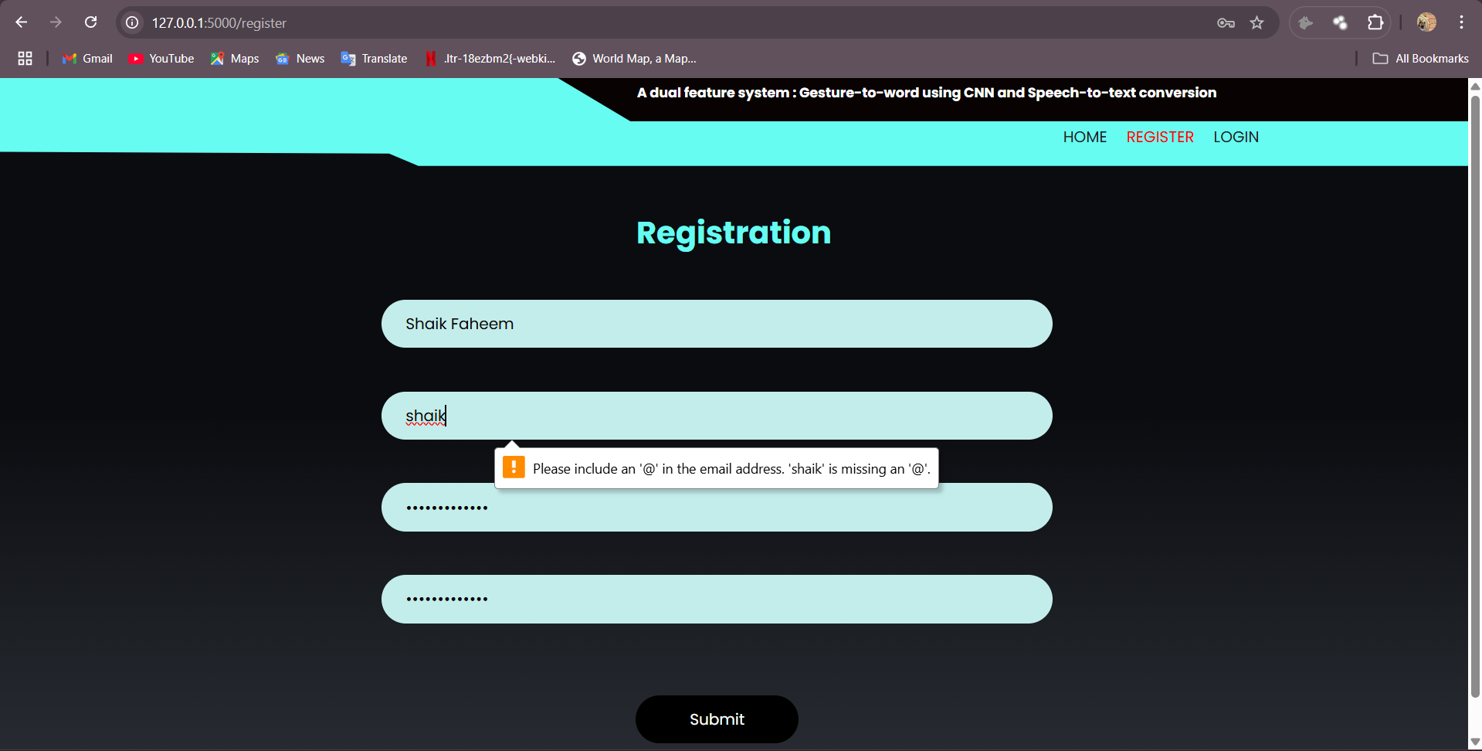

**Result: Please include @ in the email address.**

**Test Case 1b: email validation pass.**

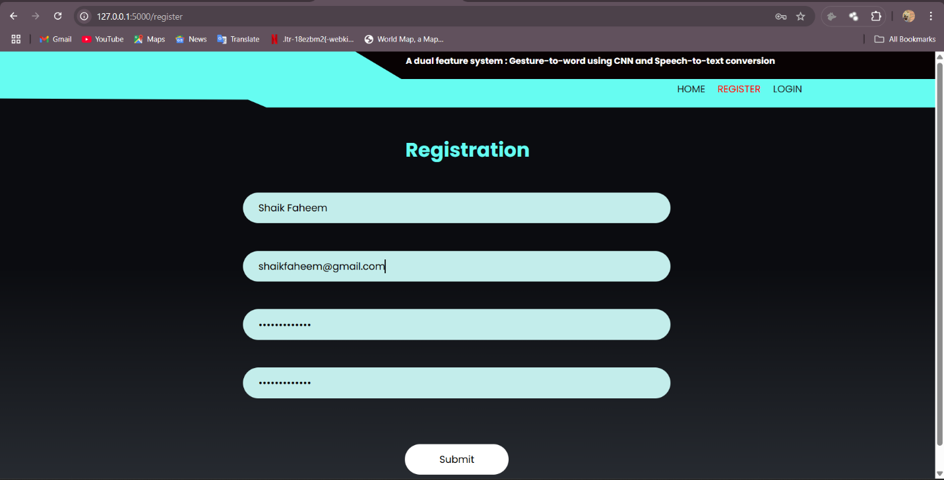

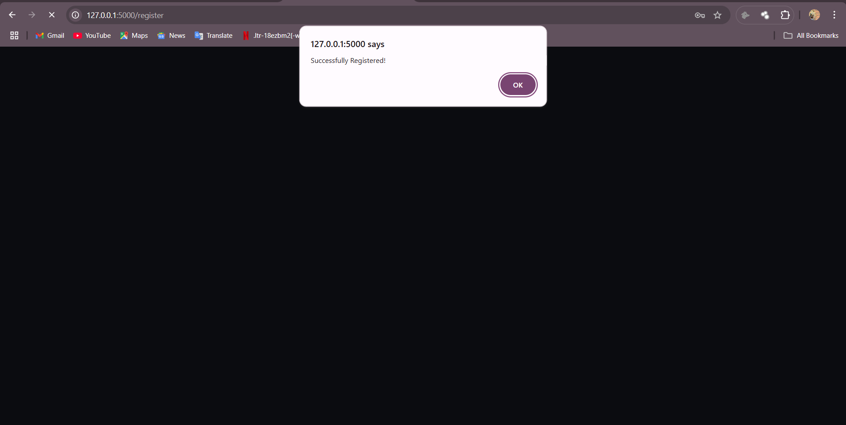

**Result: User registered**

**Test Case 2a: Password Validation(fails).**

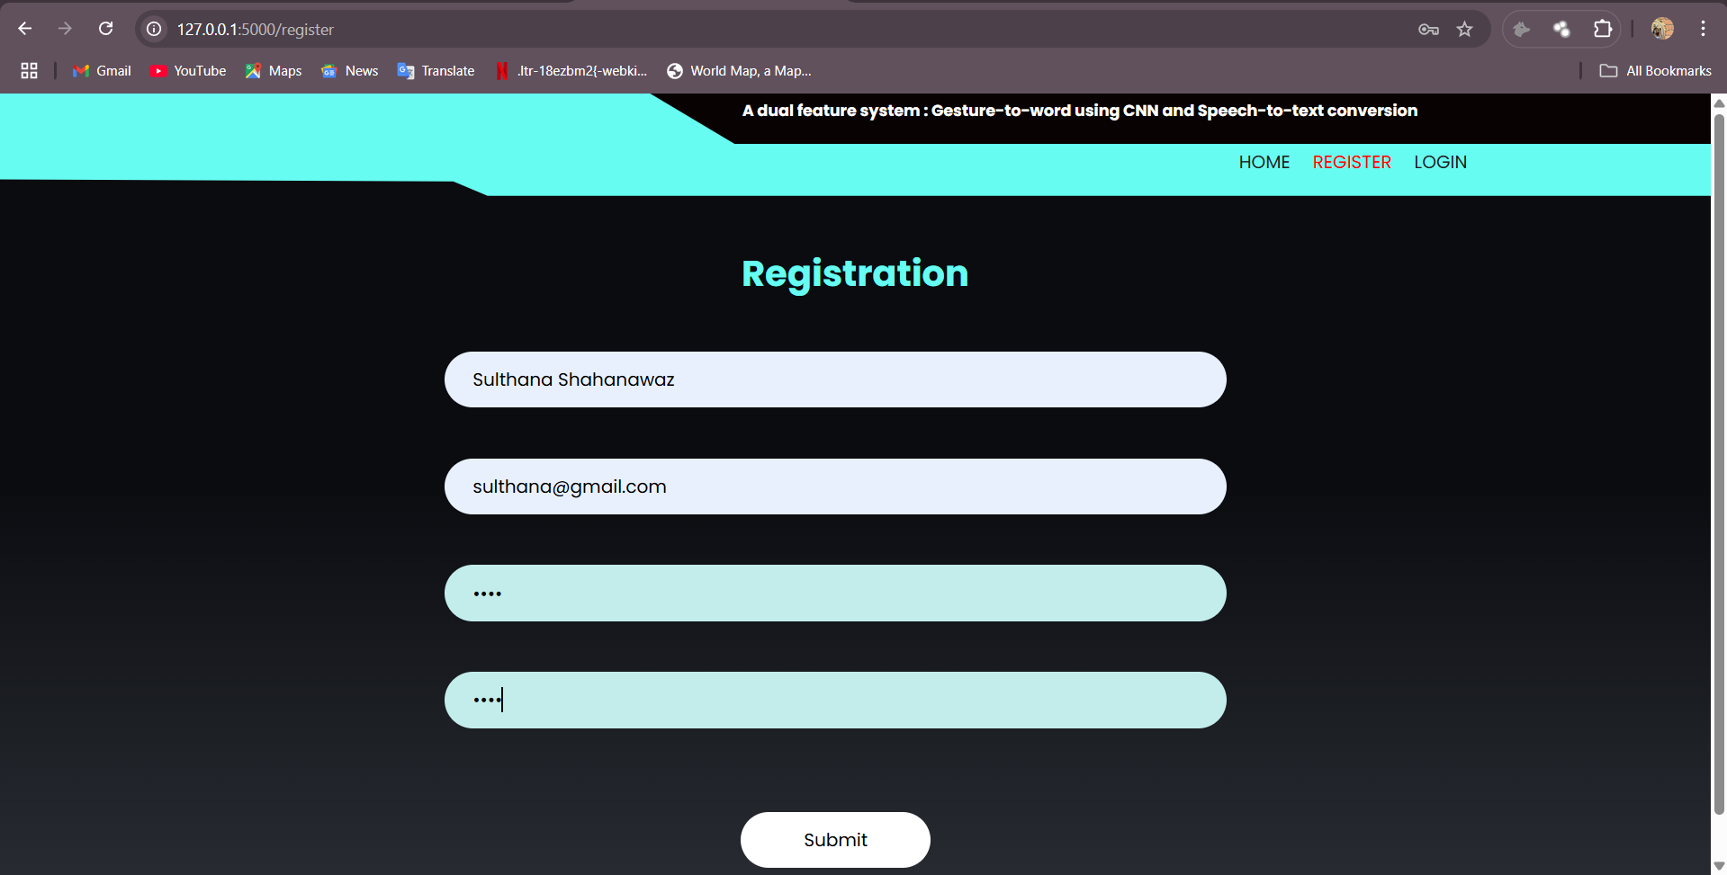

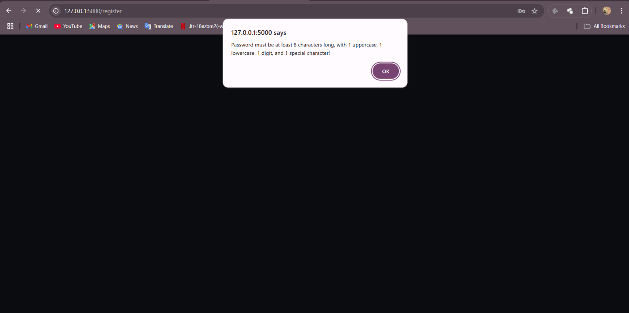

**Result: Password validation message.**

**Test Case 2b: Password Validation pass**

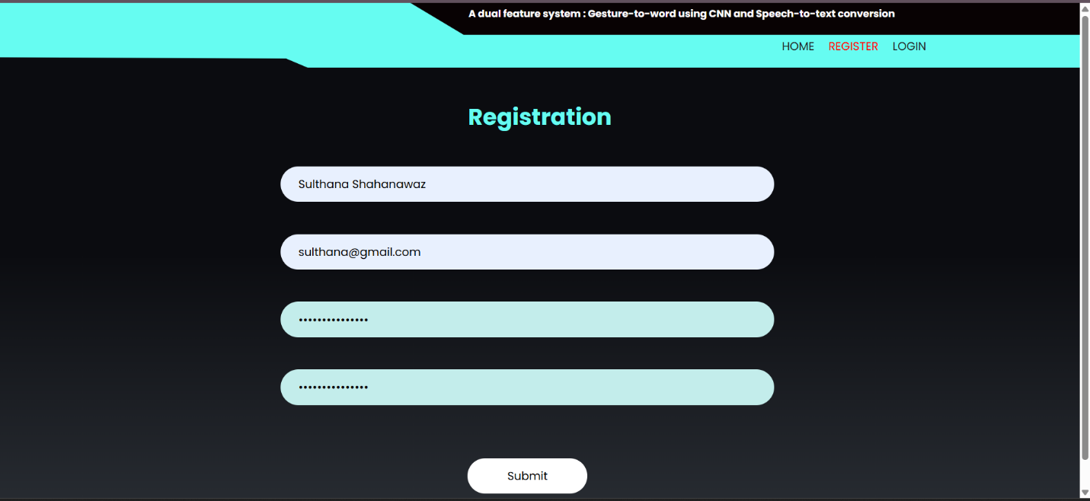

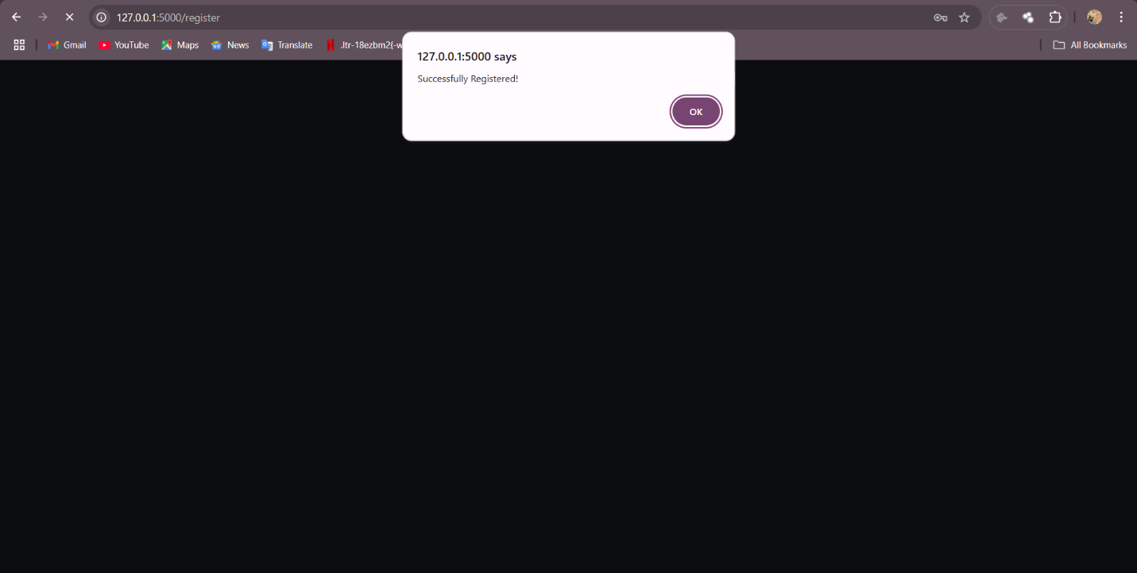

**Result: User registered**

**Test case 3: Confirm Password doesn’t match  
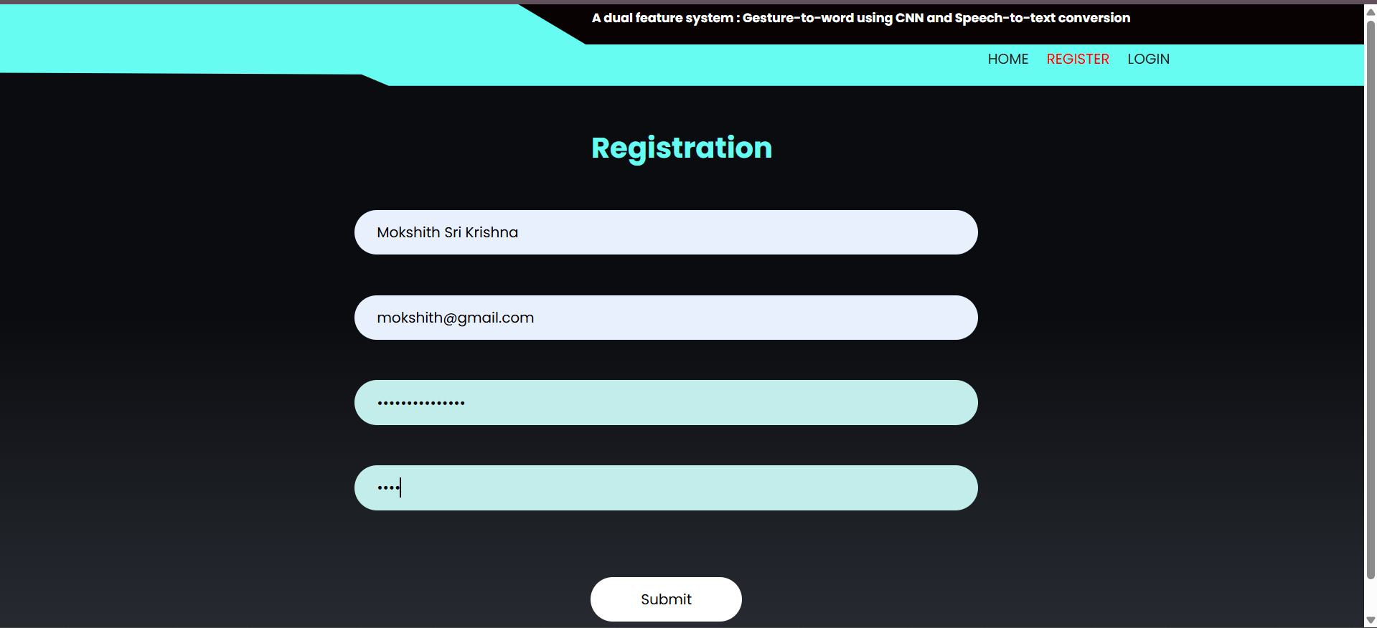**

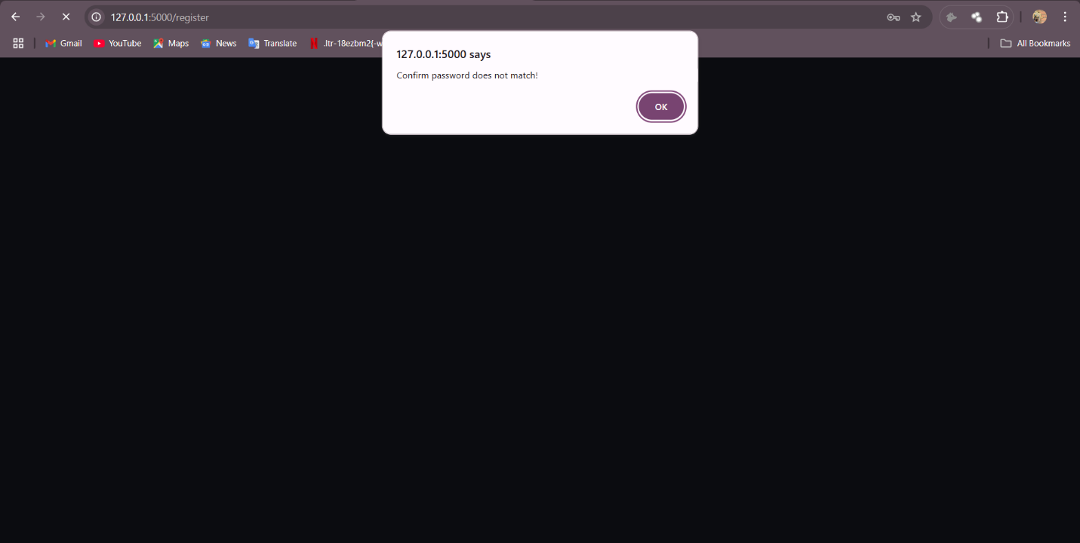

**Result: Confirm password doesn’t match**

**Test Case 4: Empty field validation**

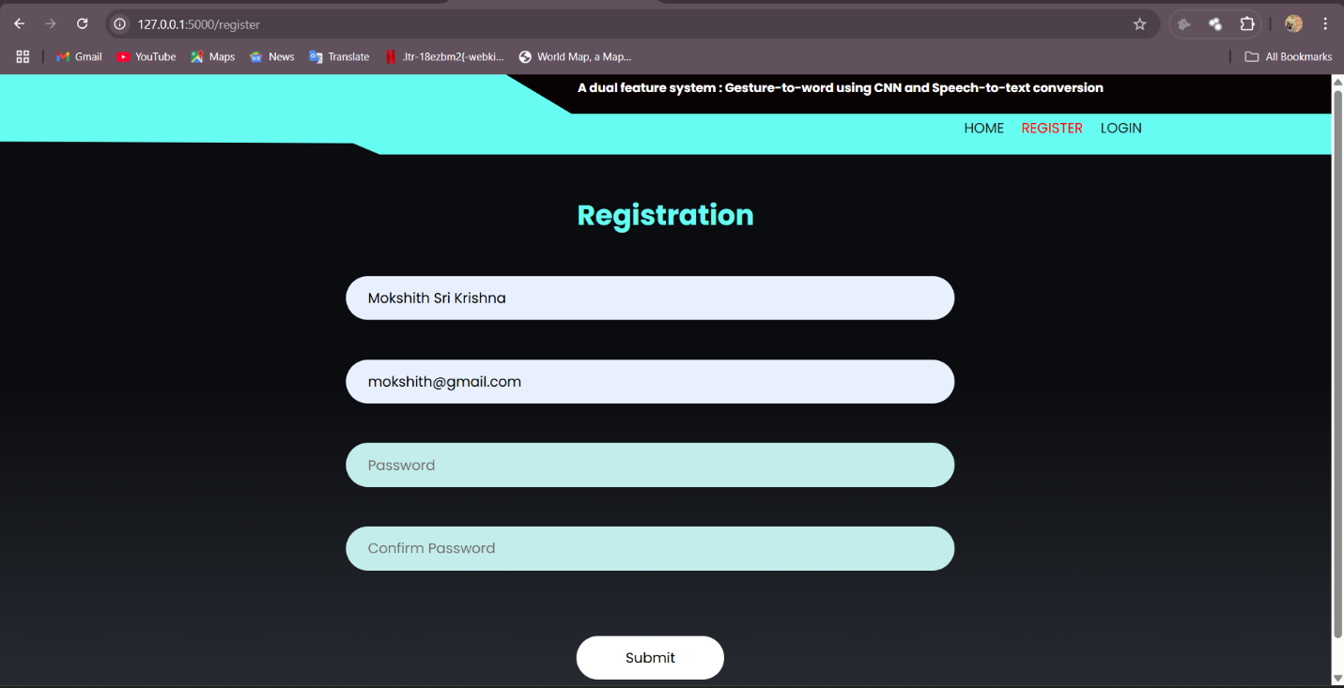

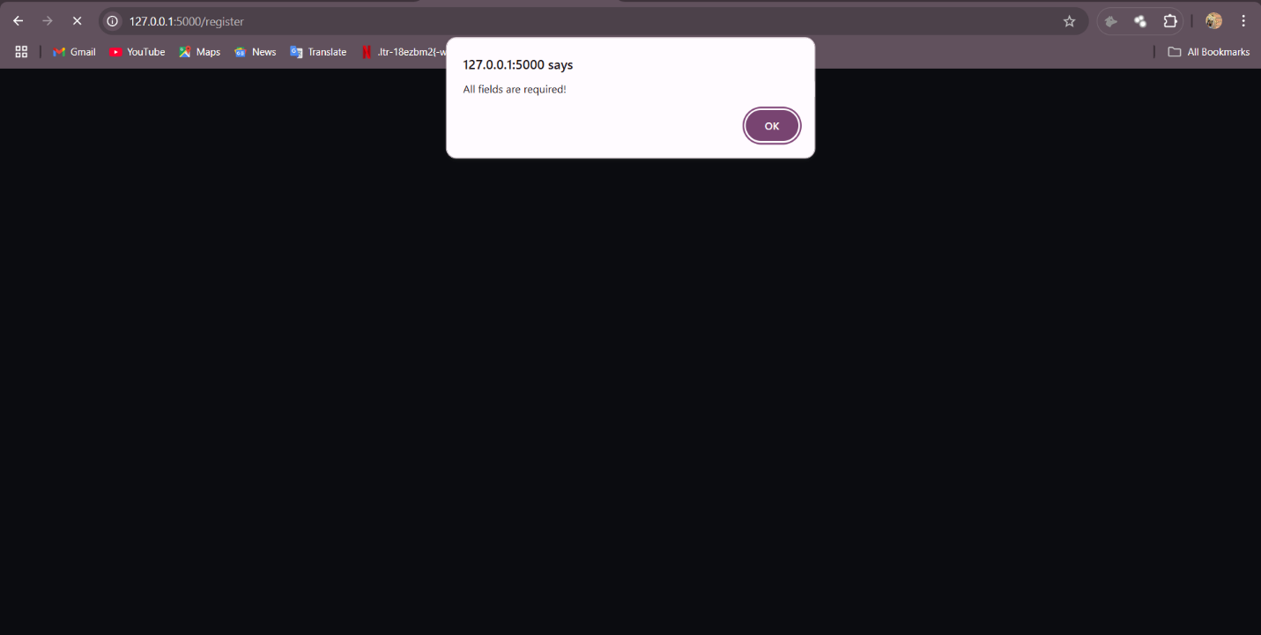

**Result: All fields are required.**

**User Authentication:**

* **Description:** Verify that a user can authenticate and log in to the speech-to-text and gesture recognition system.
* **Test Steps:**

1. Access the system's login page hosted on the local server using XAMPP (Apache and MySQL).
2. Enter valid credentials (username and password) registered previously.
3. Click on the "Login" button.
4. Expected Results: The system should authenticate the user and redirect them to the home page, where they can access speech-to-text and gesture recognition functionalities.
5. Actual Results: User "testuser" successfully signed into the website using XAMPP-hosted MySQL database. The credentials entered (username: testuser, password: testPass@123) matched the stored credentials in the MySQL database. The system authenticated the user correctly, and the user was redirected to the home page, enabling access to upload audio and start the webcam for gesture recognition.

**Test Case1: Registered user is logged in successfully.**  
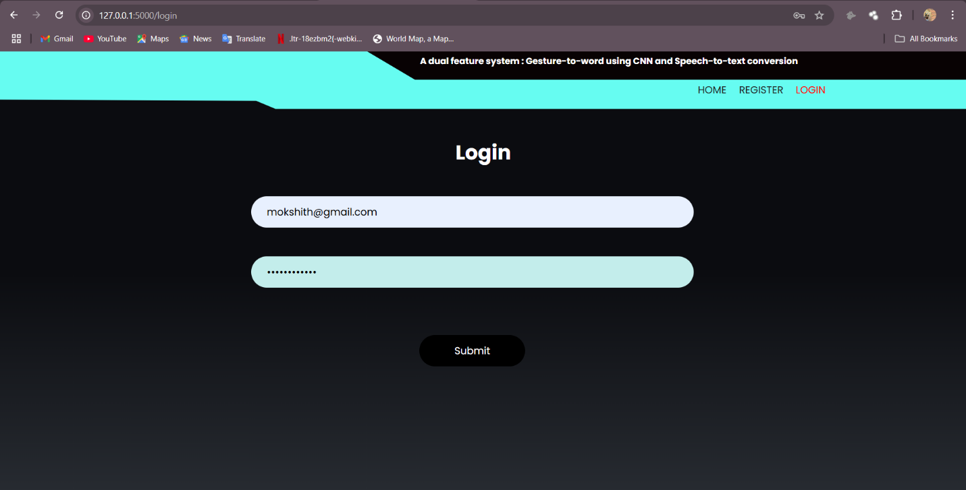

**Result: Home page is opened.**  
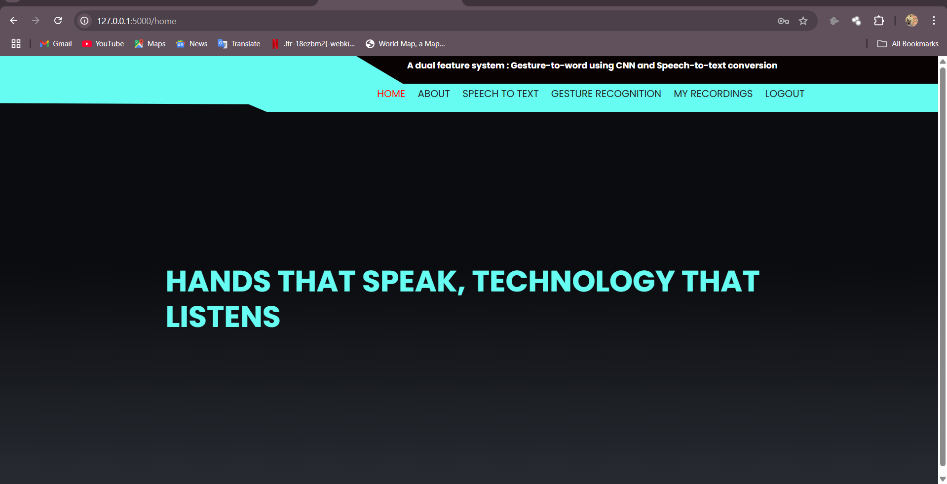

**Test Case 2: Invalid Credentials**

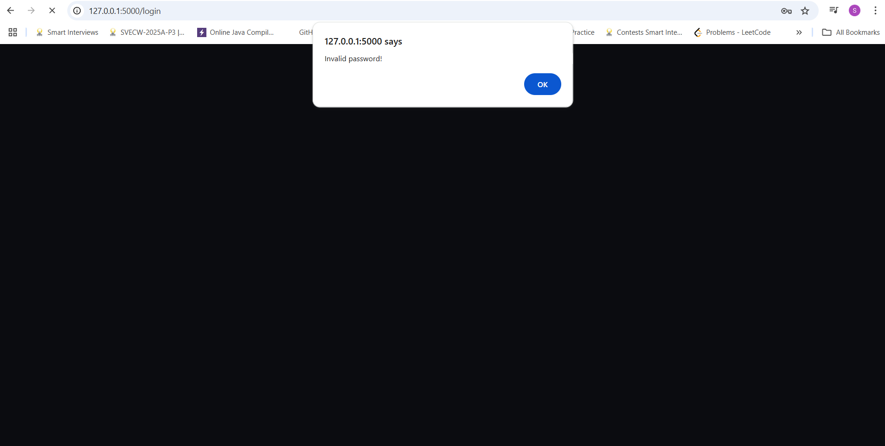

**Result: Invalid Password prompt is displayed**

**Gesture Input Functionality:**

* **Description:** Verify that the gesture input system correctly captures user gestures via the webcam, processes them using the prediction engine, and displays the results accurately, including confirming predicted letters and handling spaces between words.
* **Test Steps:** 
  1. Access the prediction page of the gesture and audio recognition system by navigating to the /prediction route (e.g., http://localhost:5000/prediction).
  2. Click the "Start Recording" button to initiate the /open_webcam route, which triggers the live.py script.
  3. Ensure a webcam is connected and active, then perform a predefined gesture (e.g., a hand sign representing a letter like "A") in front of the webcam.
  4. Observe the real-time output on the window, where the system predicts an alphabet based on the gesture.
  5. Press the Enter key to confirm the predicted letter (e.g., "A") and add it to the output text.
  6. Perform another gesture (e.g., a space gesture or a specific sign) and press the Space key to insert a space between words.
  7. Repeat steps 3-6 for additional letters (e.g., "B") and spaces to form a word or phrase (e.g., "A B").
  8. Stop the webcam feed by clicking a stop button (if implemented).
* **Expected Results:** 
  1. The webcam feed should start successfully, displaying the user’s gestures in real-time.
  2. The system should process the gesture input using the prediction engine (TensorFlow/Keras model with cvzone) and generate a prediction of an alphabet.
  3. The PredictResults should be accurately computed and displayed on the prediction.html page or a related interface, matching the performed gesture (e.g., gesture for "A" predicts "A").
  4. Pressing the Enter key should confirm the predicted letter and append it to the output text (e.g., typing "A" after confirmation).
  5. Pressing the Space key should insert a space between confirmed letters or words (e.g., "A B" after confirming "A", spacing, and "B").
  6. The webcam feed should stop cleanly without errors when terminated.
* **Validations:** 
  1. Webcam Activation: The system must detect and activate the webcam without errors (e.g., no "Camera not found" messages).
  2. Gesture Detection: The prediction engine must recognize the gesture within a reasonable time frame (e.g., <2 seconds) and with acceptable accuracy (e.g., >80% for predefined alphabet gestures).
  3. Result Display: The displayed result must correspond to the performed gesture (e.g., gesture for "A" displays "A" after Enter is pressed).
  4. Letter Confirmation: Pressing the Enter key must correctly confirm the predicted letter and update the output text without duplication or errors.
  5. Space Handling: Pressing the Space key must insert a space between confirmed letters or words accurately, ensuring proper word separation.

**Testcase1: Prediction of a single alphabet one at a time**

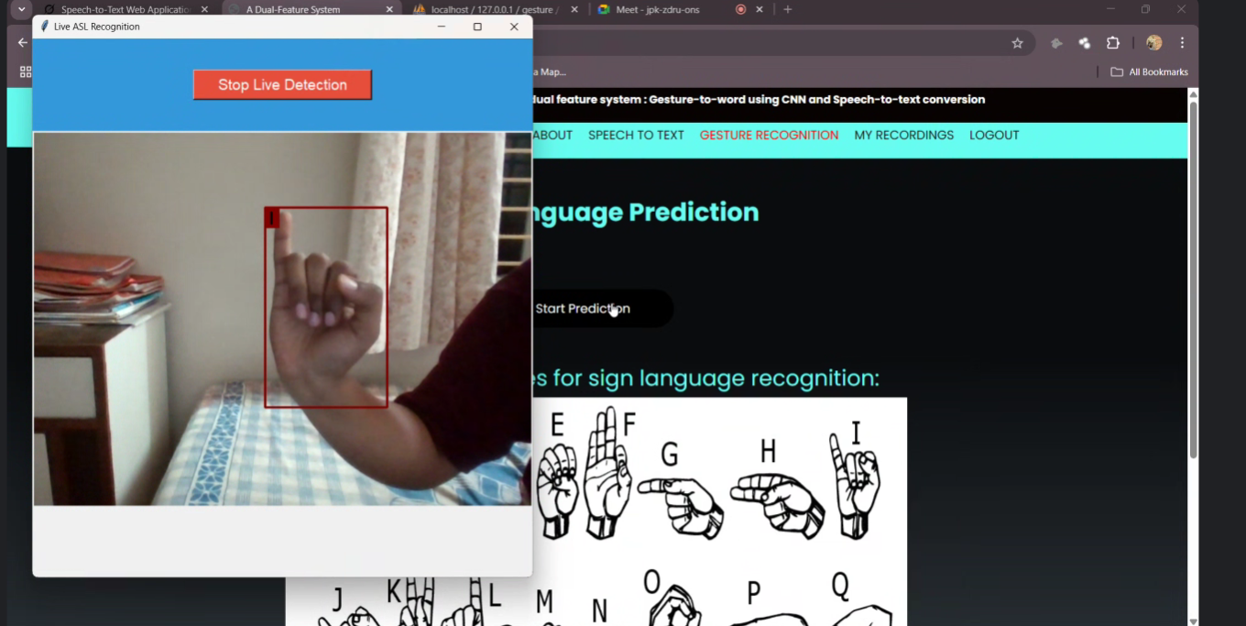

**Result: Corresponding single alphabet is predicted.**

**Testcase 2: Formation of a word by confirming alphabet by clicking ‘Enter’ key and ‘Spacebar’ for spaces.**



**Result: A word is formed from the corresponding alphabets by confirming alphabet by clicking ‘Enter’ key and ‘Spacebar’ for spaces.**

**Speech to Text Module:**

* **Description:** Verify that the user can successfully use the speech-to-text module to record audio, stop recording, and convert spoken words into text using the transcribe functionality.
* **Test Steps:**

1. Access the home page after logging in as a user on the local server using XAMPP (Apache and MySQL).
2. Navigate to the speech-to-text module from the home page.
3. Click the "Start Recording" button to begin audio capture.
4. Speak a short phrase (e.g., "Hello, this is a test").
5. Click the "Stop Recording" button to end the audio capture.
6. Click the "Transcribe" button to convert the recorded audio into text.

* Expected Results: The system should successfully record the spoken phrase, stop the recording, and upon clicking the "Transcribe" button, convert the audio into text (e.g., "Hello, this is a test") using the Google Web Speech API. The recognized text should be displayed to the user, and the audio file with the processed text should be saved in "My Recordings."
* Actual Results: User navigated to the speech-to-text module after logging in. The user clicked "Start Recording," spoke "Hello, this is a test," and then clicked "Stop Recording." Upon clicking the "Transcribe" button, the system processed the audio using the Google Web Speech API and displayed the text "Hello, this is a test" correctly. The audio file with the processed text was successfully saved in "My Recordings" within the XAMPP-hosted environment.

**Test case 1: User records speech**

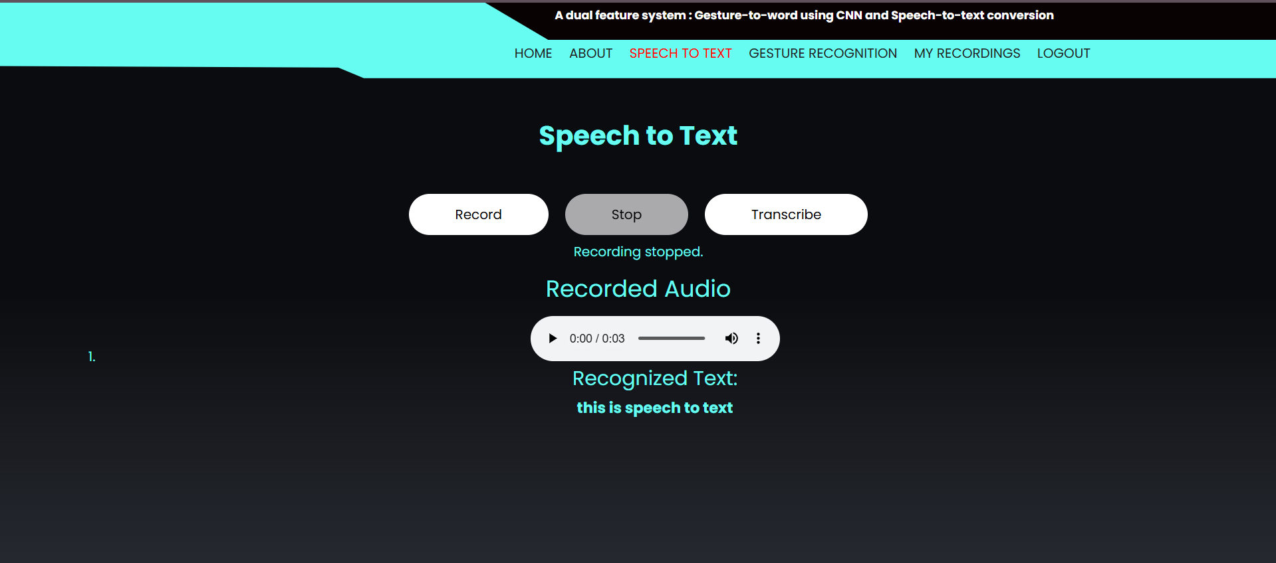

**Result: User spoken speech is recorded as a mp3 file and able to be played.**

**Test Case 2: User doesn’t speak while recording**

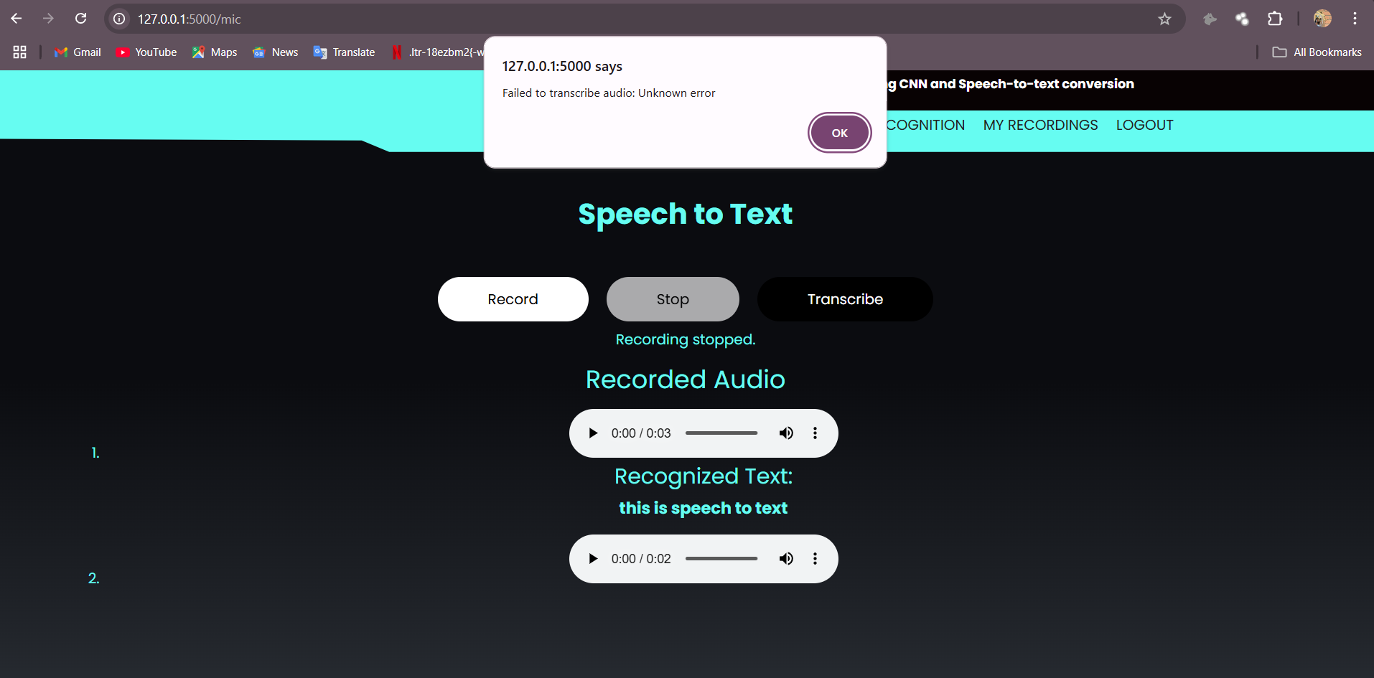

**Result: error pops up**

**My Recordings Storage and Deletion:**

* **Description:** Verify that the user’s spoken audio file and its corresponding transcribed text are stored in the "My Recordings" section with the recording date, and that the user can delete a recording using the delete option.
* **Test Steps:**

1. Access the home page after logging in as a user on the local server using XAMPP (Apache and MySQL).
2. Navigate to the speech-to-text module and record a short audio (e.g., speak "This is a test recording").
3. Stop the recording and click the "Transcribe" button to convert the audio into text.
4. Navigate to the "My Recordings" section to view the stored audio file and its transcribed text.
5. Verify the date of the recording is displayed alongside the audio file and transcribed text.
6. Select the recorded audio file and click the "Delete Recording" option to remove it.

* **Expected Results:** The system should store the recorded audio file and its transcribed text (e.g., "This is a test recording") in the "My Recordings" section, along with the correct recording date (e.g., March 08, 2025). The user should be able to delete the recording, and the audio file and its corresponding text should no longer appear in the "My Recordings" section after deletion.
* **Actual Results:** User recorded an audio saying "This is a test recording" in the speech-to-text module. After transcription, the audio file and its transcribed text "This is a test recording" were successfully stored in the "My Recordings" section in the XAMPP-hosted MySQL database. The recording date was displayed as "March 08, 2025." The user then selected the recording and clicked "Delete Recording," which removed the audio file and its transcribed text from the "My Recordings" section as expected, with no trace of the recording remaining in the database.

**Test case: History of recordings**

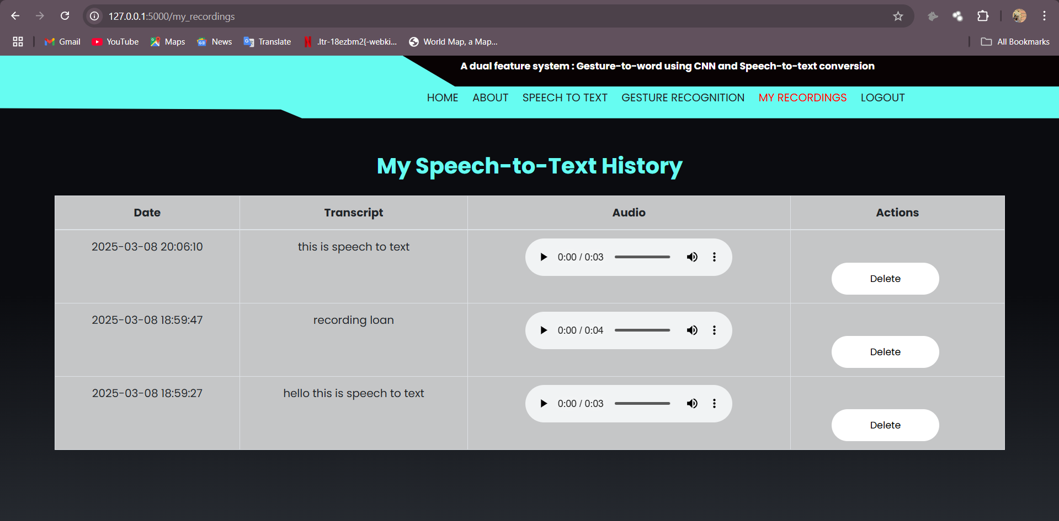

**Result: A page with all recording history is displayed**

**Test Case: Deleting a recording.**

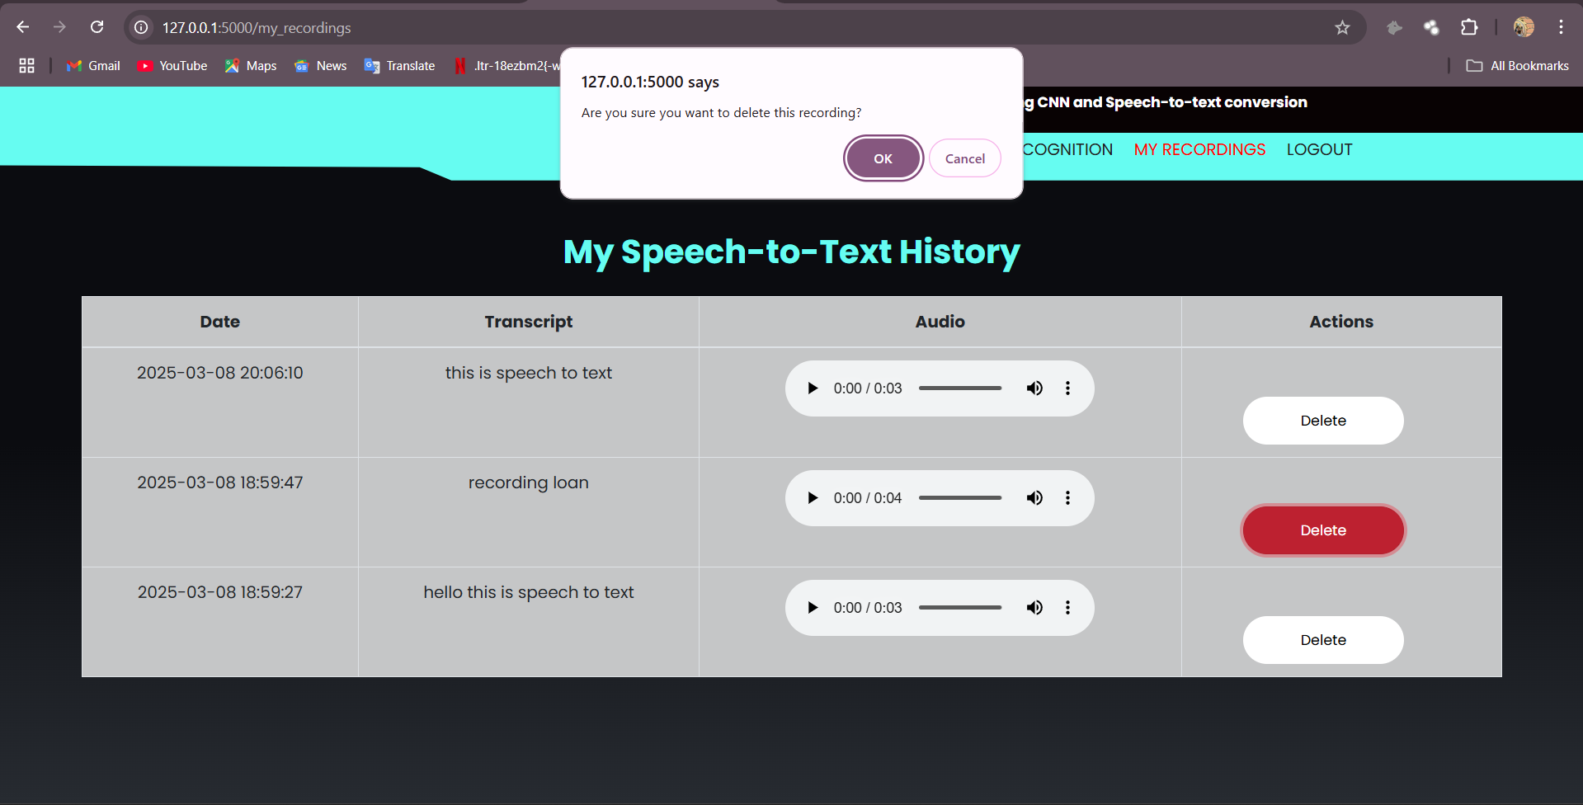  
after confirming that particular recording will be deleted.

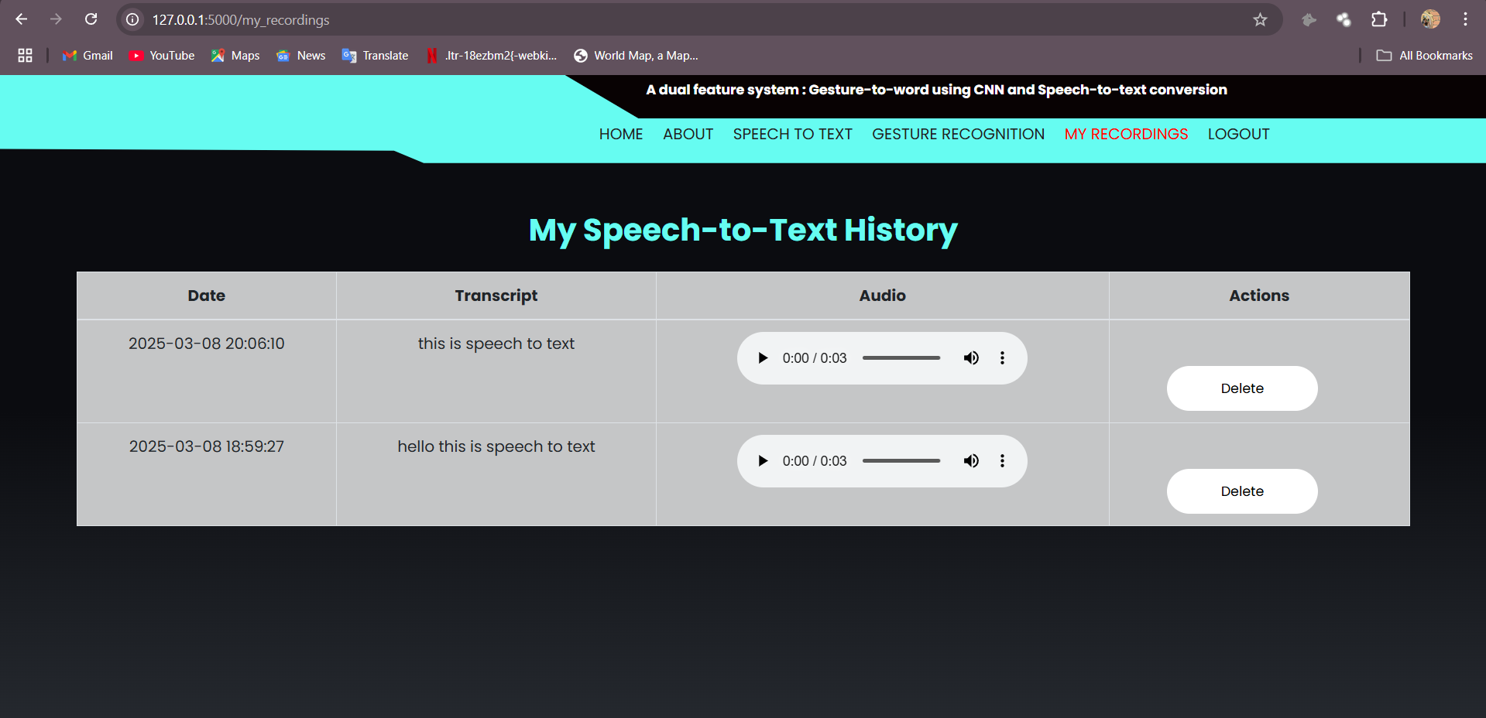

**Result: Selected recording is deleted**

**User Logout:**

* **Description:** Verify that a user can successfully log out of the speech-to-text and gesture recognition system.
* **Test Steps:**

1. Access the system's home page after logging in as a user on the local server using XAMPP (Apache and MySQL).
2. Locate and click on the "Logout" button or link on the home page or user dashboard.
3. Confirm the logout action if prompted by the system.

* **Expected Results:** The system should terminate the user’s session, log the user out, and redirect them to the login page.
* **Actual Results:** User "testuser123" was logged into the website using the XAMPP-hosted MySQL database. After clicking the "Logout" button on the home page, the system terminated the session successfully. The user was redirected to the login page, and attempts to access the home page again required re-authentication with valid credentials.

**7.CONCLUSION**

In conclusion, the integration of deep learning and speech recognition techniques in Real-Time demonstrates the potential of technology in enhancing accessibility for individuals with speech and hearing impairments. This project successfully employs MobileNet as a feature extractor for American Sign Language (ASL) gesture recognition and leverages the Google Web Speech API for real-time speech-to-text conversion, creating an effective and inclusive dual-feature system.

Our work began with an extensive study of assistive technologies, emphasizing the need for real-time solutions that connects the deaf and mute community. Recognizing the advancements in convolutional neural networks (CNNs) and pre-trained models, we adopted MobileNet to extract meaningful features from ASL gesture images while ensuring computational efficiency. Additionally, we incorporated SpeechRecognition and the Google-Web-Speech API to process speech input, enabling seamless real-time transcription.

The implementation phase involved dataset collection, preprocessing, and model fine-tuning to optimize performance.

Data augmentation techniques, such as rotation, scaling, and flipping, enhanced the diversity and robustness of the gesture recognition model. By leveraging Global Average Pooling instead of traditional oversampling techniques, we improved model efficiency while avoiding biases introduced by imbalanced datasets. Furthermore, the speech module was designed to handle real-time inputs efficiently, ensuring minimal latency and high transcription accuracy.

Evaluation results indicate that the system effectively classifies ASL gestures and converts speech into text with good precision. The gesture recognition model performed well across varying lighting conditions, hand orientations, and backgrounds, showcasing its adaptability to real-world scenarios. Similarly, the speech recognition system, supported by Google's API, provided reliable transcriptions, even in noisy environments. The integration of both modalities into a user-friendly interface further enhances the usability and practicality of the system.

Beyond technical contributions, this project highlights the broader impact of AI-driven assistive technologies in fostering inclusivity and accessibility. By providing an intuitive and efficient communication tool, we contribute to a more inclusive society where technology empowers individuals with disabilities. The implementation of real-time speech and gesture recognition paves the way for further research in multimodal systems, sign language translation, and human-computer interaction.

Moving forward, future work may explore the integration of natural language processing (NLP) for contextual understanding, expanding the ASL vocabulary for more comprehensive communication, and developing mobile-friendly applications for wider accessibility. Collaborations with linguists, speech therapists, and accessibility researchers could further enhance the system’s effectiveness and usability.

In conclusion, this project successfully demonstrates the potential of deep learning and AI in assistive communication, bridging communication barriers for individuals with hearing and speech impairments. By harnessing the power of CNN-based gesture recognition and speech-to-text conversion, we take a significant step toward creating a more inclusive and accessible world where technology serves as a vital enabler of human interaction.

**8. Bibliography**

[1] Abhishek B, Kanya Krishi, Meghana M, Mohammed Daaniyaal, Anupama H S. "Hand Gesture Recognition Using Machine Learning Algorithms."

[2] Syed Raquib Shareef, Mohammed Mannan Hussain. "Hand Gesture Recognition System for Deaf and Dumb."

[3] Shanthini, E., Akshaya, N., & Haritha, J. (2023, June). Hand Gesture Vocalizer using MobileNetV2 for Deaf Mutes. In 2023 3rd International Conference on Pervasive Computing and Social Networking (ICPCSN) (pp. 1481-1485). IEEE.

[4] Tiwari, A., Gangrade, A., Tiwari, A., & Bandhu, K. C. (2022). Design and Implementation of Conversion of Gesture to Voice Using OpenCV and Convolution Neural Network. In Information and Communication Technology for Competitive Strategies (ICTCS 2020) ICT: Applications and Social Interfaces (pp. 921-930). Springer Singapore.

[5] Kim, S. Y., Urm, S. J., Yoo, S. Y., Kim, S. J., & Lee, K. M. (2023). Application of Sign Language Gesture Recognition Using Mediapipe and LSTM. Journal of Digital Contents Society, 24(1), 111-119.

[6] Bogdan Iancu. “Evaluating Google Speech-to-Text API’s Performance for Romanian e-Learning Resources”

[7] Dr. Kavitha R., Nachammai N., Ranjani R., Shifali J. "Speech Based Voice Recognition System for Natural Language Processing"

[8] Reddy, V. M., Vaishnavi, T., & Kumar, K. P. (2023, July). Speech-to-Text and Text-to-Speech Recognition Using Deep Learning. In 2023 2nd International Conference on Edge Computing and Applications (ICECAA) (pp. 657-666). IEEE.

[9] Amrutha, K., & Prabu, P. (2023). Evaluating the pertinence of pose estimation model for sign language translation. International Journal of Computational Intelligence and Applications, 22(01), 2341009.

[10] Elakkiya, A., Surya, K. J., Venkatesh, K., & Aakash, S. (2022, December). Implementation of speech to text conversion using hidden markov model. In 2022 6th International Conference on Electronics, Communication and Aerospace Technology (pp. 359-363). IEEE.

[11] Raju, M. D. N. G., Reddy, A. R., Pranith, P. S., Nikhil, L. S., Pasha, S., & Bhat, P. V. (2022). Hand Gesture Recognition And Voice Conversion For Deaf And Dumb. Journal of Positive School Psychology, 6(7), 4953-4960.

[12] Aasofwala, N., Verma, S., & Patel, K. (2023, July). NLP based model to convert English speech to Gujarati text for deaf & dumb people. In 2023 14th International Conference on Computing Communication and Networking Technologies (ICCCNT) (pp. 1-6). IEEE.

**9. Appendix**

**9.1 Introduction to Python :**

Python has established itself as the dominant programming language for deep learning applications, owing to its simplicity, versatility, and an extensive ecosystem of libraries. In the context of "A Dual-Feature System: Gesture-to-Word Using CNN and Speech-to-Text Conversion," Python plays a crucial role in implementing both gesture recognition and speech-to-text processing. With a vast collection of deep learning frameworks, image processing libraries, and speech recognition tools, Python serves as the backbone of the project, enabling efficient development and deployment of both modules.

For the Gesture-to-Word Module, Python’s deep learning frameworks such as TensorFlow and Keras facilitate the creation and training of convolutional neural networks (CNNs) to recognize hand gestures. TensorFlow, an open-source library developed by Google, provides a highly optimized computational environment that accelerates the training and inference of deep learning models. Keras, now integrated into TensorFlow, offers an intuitive high-level API, simplifying the design of CNN architectures for real-time gesture recognition. Additionally, OpenCV, a powerful computer vision library, is extensively used for preprocessing gesture images, extracting hand contours, and applying transformations that enhance model performance.

For the Speech-to-Text Module, Python provides robust speech processing libraries such as SpeechRecognition and Google Web Speech API, which allow seamless conversion of spoken words into text. The SpeechRecognition library supports multiple speech-to-text engines, enabling developers to integrate high-accuracy transcription services into their applications. Additionally, pydub and librosa are employed for audio preprocessing, including noise reduction, sampling rate conversion, and feature extraction, ensuring better recognition accuracy. For advanced speech recognition, deep learning models like Wav2Vec2 from Hugging Face’s Transformers library can be fine-tuned on speech datasets to improve transcription performance in noisy environments.

Python’s strength also lies in its extensive ecosystem of supporting libraries, which streamline data handling and visualization. NumPy and Pandas provide efficient data structures for handling numerical and tabular data, crucial for managing gesture datasets and speech transcripts. Matplotlib and Seaborn offer visualization tools that assist in analyzing model performance, visualizing training curves, and debugging potential issues. These tools enhance the interpretability of deep learning models and facilitate informed decision-making throughout the development process.

Furthermore, Python’s compatibility with Transfer Learning techniques accelerates model training by leveraging pre-trained architectures such as MobileNetV2, ResNet50, and VGG16 for gesture recognition. Instead of training CNN models from scratch, Transfer Learning allows developers to fine-tune existing models trained on large-scale datasets like ImageNet, significantly reducing computational costs and improving classification accuracy. This is particularly beneficial for real-time gesture recognition applications, where efficiency and responsiveness are critical.

The interactive nature of Jupyter Notebooks enhances Python’s usability in deep learning projects. Jupyter Notebooks allow developers to write, test, and visualize code in an iterative manner, making it easier to debug and refine deep learning models. This interactive workflow is instrumental in fine-tuning hyperparameters, analyzing feature maps, and experimenting with different CNN architectures for optimal performance.

In conclusion, Python serves as the foundation for developing both modules of the Gesture-to-Text and Speech-to-Text System. Its powerful deep learning frameworks, computer vision and speech processing libraries, and visualization tools make it an indispensable language for implementing AI-driven applications. The seamless integration of TensorFlow for CNN-based gesture recognition and SpeechRecognition for speech-to-text conversion ensures that Python remains at the forefront of enabling accessibility solutions. As deep learning continues to advance, Python's flexibility and rich ecosystem will continue to drive innovation in assistive communication technologies.

**9.2 Introduction to Convolutional Neural Network (CNN) Algorithm**

Convolutional Neural Networks (CNNs) are a specialized class of deep learning models designed for processing structured grid data, primarily images. They have significantly transformed the fields of computer vision, natural language processing, and speech recognition by effectively capturing spatial and hierarchical patterns within data. CNNs utilize convolutional operations to automatically extract relevant features from input data, eliminating the need for manual feature engineering. Their ability to learn spatial hierarchies and recognize patterns makes them highly effective in tasks like object recognition, image classification, and gesture recognition.

**Architecture of CNNs**

CNNs are composed of multiple layers that work in tandem to process and analyze image data. The core building blocks include convolutional layers, pooling layers, activation functions, and fully connected layers. Convolutional layers apply learnable filters (kernels) to the input image, capturing essential features such as edges, textures, and patterns. These feature maps serve as the foundation for higher-level pattern recognition. Pooling layers, such as max pooling and average pooling, reduce the spatial dimensions of feature maps, thereby improving computational efficiency and ensuring translation invariance. Activation functions like ReLU (Rectified Linear Unit) introduce non-linearity, allowing CNNs to learn complex relationships within the data. The final layers are fully connected layers, which map the extracted features to the desired output, such as classification labels in an image recognition task.

**Training Process**

The training process of CNNs involves backpropagation and gradient descent optimization to fine-tune model parameters. CNNs minimize a predefined loss function by adjusting weights and biases through iterative learning. During forward propagation, the input passes through the network, and the output is compared with the expected result to compute the loss. In backward propagation, gradients of the loss function with respect to network parameters are computed using techniques like stochastic gradient descent (SGD), Adam, or RMSprop. The model updates its parameters based on these gradients to improve accuracy over multiple iterations. With each training cycle, CNNs become more adept at recognizing patterns and making accurate predictions.

**Key Components and Techniques**

Several advanced techniques enhance the efficiency and performance of CNNs. Batch normalization standardizes the activations of each layer, accelerating training and improving convergence. Dropout regularization prevents overfitting by randomly deactivating certain neurons during training, ensuring the network generalizes well to unseen data. Data augmentation techniques such as image rotation, flipping, scaling, and cropping artificially expand the training dataset, improving the model’s ability to handle variations in real-world scenarios. Additionally, Transfer Learning allows CNNs to leverage pre-trained models like MobileNet, ResNet, and VGG for tasks with limited training data, significantly reducing computational costs while maintaining high accuracy.

**Applications of CNNs**

CNNs have found extensive applications across diverse domains. In image classification, CNNs have set new benchmarks in competitions like ImageNet. Object detection techniques powered by CNNs are widely used in surveillance, autonomous driving, and medical imaging. Facial recognition systems employ CNNs for identity verification in security applications. In medical image analysis, CNNs assist in diagnosing diseases from X-rays, MRIs, and CT scans. Additionally, CNNs are now being integrated into natural language processing (NLP), enabling advancements in text classification, sentiment analysis, and speech recognition. In gesture-based communication, CNNs play a crucial role in recognizing sign language, enabling accessibility solutions for individuals with hearing or speech impairments.

In conclusion, CNNs have revolutionized deep learning applications by providing an efficient mechanism for learning hierarchical features from image and video data. Their ability to automatically extract and refine features has made them indispensable in fields like computer vision, healthcare, security, and human-computer interaction. As research in deep learning progresses, CNN architectures continue to evolve, unlocking new possibilities for real-time AI-driven applications.

**9.3** **Introduction to MobileNet Architechture :**

MobileNet is a widely recognized convolutional neural network (CNN) architecture specifically designed for efficient use on mobile and embedded devices. It addresses the challenge of deploying deep learning models with high performance on resource-constrained platforms. Here's a breakdown of the MobileNet architecture:

**Depthwise Separable Convolution:**

At the core of MobileNet is the depthwise separable convolution, which consists of two main operations: depthwise convolution and pointwise convolution. This approach significantly reduces the number of parameters and computations compared to traditional convolutional layers. Depthwise convolution applies a single filter per input channel, while pointwise convolution combines the output of depthwise convolution across channels with 1x1 convolutions.

**Depthwise Convolution:**

In depthwise convolution, each input channel is convolved separately with its corresponding set of filters. This step allows the model to capture spatial information within each channel independently.

**Pointwise Convolution:**

Pointwise convolution follows depthwise convolution and involves applying a 1x1 convolution to the output of the depthwise convolution. This operation helps in combining features from different channels and generating the final output.

**Width Multiplier and Resolution Multiplier:**

MobileNet introduces two hyperparameters: width multiplier and resolution multiplier, which allow for adjusting the size and computational complexity of the model. The width multiplier scales the number of channels in each layer, while the resolution multiplier scales down the input image resolution, effectively reducing the number of computations.

**Architecture Variants:**

MobileNet comes in various versions such as MobileNetV1, MobileNetV2, and MobileNetV3, each offering improvements in terms of accuracy, speed, and efficiency. MobileNetV2, for instance, introduces inverted residual blocks with linear bottlenecks to improve the flow of information and reduce computational costs.

**Applications and Advantages:**

MobileNet architectures are widely used in various computer vision applications on mobile and embedded devices, including image classification, object detection, and semantic segmentation. The lightweight nature of MobileNet makes it suitable for real-time inference on devices with limited computational resources, enabling deployment in scenarios like mobile apps, drones, and IoT devices.

In summary, MobileNet's innovative architecture, leveraging depthwise separable convolutions and hyperparameters like width and resolution multipliers, enables efficient deep learning inference on mobile and embedded platforms, making it a popular choice for resource-constrained environments.

**9.4** **Introduction to HTML:**

In the realm of deep learning for gesture-to-word and speech-to-text conversion, integrating an intuitive and user-friendly interface is essential for seamless interaction between users and the underlying model. HTML, as the standard markup language for creating web pages, plays a crucial role in designing the user interface (UI) for processing live-cam feed and recording speech input. This section explores the significance of HTML in this context, emphasizing its role in improving accessibility and engagement in gesture and speech recognition systems.

HTML, or HyperText Markup Language, serves as the fundamental building block of the World Wide Web. It structures content on web pages by defining elements such as headings, paragraphs, images, forms, and buttons. In the context of this project, HTML provides the foundation for the UI, facilitating users in processing live-cam feed for recognition and recording speech for transcription. By structuring the interface with HTML, developers ensure that the platform remains intuitive and user-friendly.

The first step in engaging users in gesture-to-word and speech-to-text conversion is to create an intuitive input interface. The <button> element can be utilized to trigger the live-cam and speech recording process, ensuring users can interact effortlessly with the system. This simple yet effective setup encourages users to engage with the application and leverage its functionalities with ease.

HTML5 introduces advanced features that further enrich the user experience. The accept attribute in file upload inputs can be used to restrict submissions to specific formats, ensuring compatibility with the recognition model. Additionally, HTML5’s <audio> and <video> elements enhance the interface by allowing users to preview their recorded speech or uploaded gestures before submission. Features like drag-and-drop functionality for images improve convenience, making the process more interactive.

While HTML provides the structure for the UI, JavaScript complements it by adding interactivity. JavaScript can be used to validate file formats, provide real-time feedback, and enhance user engagement in the speech recording and gesture recognition processes. For example, it can be used to display a visual indicator when the system is actively recording speech or processing an gesture, thereby improving the user experience.

HTML seamlessly integrates with backend technologies, serving as the bridge between the user interface and deep learning models. When a user give live-feed of gesture or records speech, the HTML form submits the data to a server endpoint, where backend frameworks like Flask handle processing. These backend technologies then pass the data to trained machine learning models, which generate results and return them to be displayed on the HTML page.

HTML’s flexibility extends to responsive design, ensuring the interface is accessible across different devices and screen sizes. Users may access the platform from various devices, ranging from smartphones to desktop computers, making responsiveness an essential factor. By using modern design principles, developers can craft an HTML-based UI that adapts dynamically, ensuring seamless usability.

In conclusion, HTML serves as a fundamental component in developing user interfaces for gesture-to-word and speech-to-text conversion systems. Its simplicity, compatibility with other technologies, and ability to enhance the user experience make it an indispensable tool for creating intuitive input interfaces. By integrating HTML with backend technologies and incorporating responsive design principles, developers can build an accessible and engaging platform that fosters user interaction with deep learning-powered communication tools.

**9.5** **Introduction to CSS:**

In the dynamic landscape of deep learning applications for gesture-to-word and speech-to-text conversion, the user interface (UI) plays a vital role in shaping user experience. CSS, or Cascading Style Sheets, emerges as a powerful companion to HTML, enabling developers to enhance the aesthetics and usability of the UI. This section explores the significance of CSS in designing a visually appealing and functional interface for uploading gestures and recording speech.

CSS serves as the stylistic backbone of web development, allowing developers to define the presentation and layout of HTML elements. In this project, CSS is instrumental in ensuring that the UI is not only functional but also visually appealing. By leveraging CSS, developers can apply colors, fonts, and design elements that improve readability and user engagement, ensuring a seamless experience for users interacting with the system.

CSS plays a crucial role in creating responsive designs that adapt to different screen sizes and devices. Since users may access the application from smartphones, tablets, or desktops, CSS media queries enable dynamic UI adjustments. By implementing a responsive design, the interface remains visually consistent and user-friendly across various platforms, ensuring accessibility for all users.

CSS offers the ability to incorporate transitions and animations, adding a layer of sophistication to the UI. In this project, animations can be applied to buttons, form elements, and visual feedback indicators, enhancing the overall user experience. For example, a smooth transition effect can be applied when a user uploads an image, making the interaction feel more intuitive and engaging. These subtle design enhancements contribute to a polished and interactive UI.

For projects developed with a specific branding in mind, CSS enables customization to align with a defined visual identity. Colors, fonts, and logos can be seamlessly integrated into the UI, ensuring consistency with the application's branding. This is particularly useful in cases where the project is presented to institutions or companies that require a unique and recognizable interface design.

CSS operates on the principle of cascading styles, ensuring a systematic and organized approach to styling HTML elements. Additionally, it provides cross-browser compatibility, ensuring that the interface appears consistent across different web browsers. This is particularly important for gesture and speech recognition applications, as users may access the system from a variety of browsers.

In conclusion, CSS is a fundamental element in the development of user interfaces for gesture-to-word and speech-to-text conversion systems. Its role extends beyond aesthetics, encompassing responsive design, animations, and branding customization. By integrating CSS with HTML and JavaScript, developers can create visually appealing, user-friendly interfaces that enhance engagement and accessibility, ultimately improving the overall usability of the deep learning-powered application.

**9.6** **Introduction to JavaScript:**

JavaScript, a versatile and dynamic programming language, plays a crucial role in enhancing the gesture-to-word and speech-to-text conversion system's user interface. It provides interactivity, real-time feedback, and seamless communication between the frontend and backend, ensuring an engaging and responsive user experience. This section explores JavaScript’s role in improving the UI and user interaction within this project.

JavaScript enables real-time feedback mechanisms, improving user experience during live-cam feed and speech recording. By implementing event listeners, JavaScript can monitor user actions, validate file formats, and dynamically update the UI. For example, if a user is giving the gesture as live-cam feed, JavaScript can display a preview, ensuring that the correct file is selected. Similarly, during speech recording, a visual indicator can inform users that the system is actively capturing audio.

JavaScript’s ability to manipulate the Document Object Model (DOM) dynamically allows for seamless UI updates. In the context of this project, JavaScript can modify the display of classification results, progress indicators, and interactive buttons, creating a highly responsive interface. This enhances user engagement by providing instant feedback on actions such as speech recognition results or gesture classification outputs.

JavaScript facilitates asynchronous communication with the backend, allowing users to interact with the application without experiencing delays. Using AJAX or Fetch API, JavaScript can send image and audio data to the server for processing without requiring a page reload. This ensures that users receive responses quickly, improving the overall usability of the application.

By handling events such as clicks, hovers, and key presses, JavaScript enhances user engagement. For instance, JavaScript can enable a "Start Recording" button to change dynamically when the speech recognition process begins and stops. These interactive elements make the interface more intuitive and user-friendly.

JavaScript can perform client-side image and audio processing before submission, optimizing data for faster transmission. These optimizations enhance the overall performance of the recognition system.

In conclusion, JavaScript is an essential component in the development of user interfaces for gesture-to-word and speech-to-text conversion applications. Its ability to enhance interactivity, provide real-time feedback, and enable seamless backend communication makes it indispensable for creating an intuitive and engaging user experience. By integrating JavaScript with HTML and CSS, developers can craft a powerful, interactive interface that bridges the gap between users and deep learning models.

**9.7** **Introduction to Flask Framework:**

Flask, a lightweight and flexible web framework written in Python, provides an efficient and scalable solution for deploying deep learning models in the "A Dual-Feature System: Gesture-to-Word Using CNN and Speech-to-Text Conversion" project. Flask's minimalistic design allows for seamless integration with machine learning and deep learning models, making it an excellent choice for developing interactive and AI-powered applications.

**1. Flask’s Microservices Architecture:**

Flask follows a microservices-based architecture, offering modular and lightweight development capabilities. Unlike monolithic frameworks, Flask allows developers to build

individual components such as the gesture recognition module and speech-to-text module as separate services. This architecture enhances flexibility, making it easier to scale and deploy different components independently.

**2. Flask Routing and Request Handling:**

Flask provides an intuitive routing mechanism that maps user requests (HTTP requests) to specific functions. In this project, the gesture-to-word module will handle image uploads from a webcam, while the speech-to-text module will process audio recordings. Flask’s @app.route() decorator efficiently manages these request endpoints, enabling real-time interaction between users and the deep learning models.

**3. Integration of Flask with Deep Learning Models:**

Flask seamlessly integrates with deep learning frameworks such as TensorFlow, Keras, and OpenCV, allowing smooth deployment of the CNN-based gesture recognition model and speech recognition module. The trained MobileNet or CNN model for gesture classification can be loaded into Flask using TensorFlow.keras.models.load_model(), while the speech-to-text module can utilize the SpeechRecognition library via API requests.

**4. Database Management with Flask-SQLAlchemy:**

Flask-SQLAlchemy, an Object-Relational Mapping (ORM) tool, simplifies database interactions. In this project, it is used to store gesture classification results, transcribed speech text, and user activity logs. Flask’s ORM allows for easy querying and management of structured data, ensuring smooth backend operations.

**5. Flask Forms for User Input Handling:**

User interaction with the system requires gesture image uploads and voice recordings, which Flask efficiently handles through Flask-WTF forms or direct POST requests. The framework validates input data, ensuring that users upload images or audio files in the correct format before sending them for processing.

**6. API Development with Flask-RESTful:**

Flask-RESTful is employed to expose the system’s functionality via RESTful APIs. This is crucial for enabling mobile applications, web clients, or third-party services to interact with the project’s gesture-to-word and speech-to-text modules. The API endpoints handle requests for:

- Gesture classification (/predict_gesture)

- Speech transcription (/transcribe_speech)

- Text-to-Speech conversion (/speak_text)

**7. User Authentication and Security:**

For user authentication, Flask provides built-in support via Flask-Login and Flask-JWT-Extended, ensuring secure access to the system. Security measures such as Cross-Origin Resource Sharing (CORS) protection, CSRF tokens, and encryption techniques are implemented to prevent unauthorized access and data breaches.

**8. Deployment and Scalability with Flask:**

Flask applications can be deployed on various platforms, including Heroku, AWS, or Google Cloud, making them highly scalable. The project utilizes Gunicorn as a production WSGI server, improving the system’s responsiveness when handling multiple user requests simultaneously.

**9. Asynchronous Task Execution using Flask-Celery:**

Since deep learning inference tasks can be computationally expensive, Flask uses Celery along with a message broker like Redis to offload heavy tasks asynchronously. This ensures that real-time gesture classification and speech recognition run smoothly without blocking other operations.

**Conclusion:**

Flask provides an efficient, scalable, and modular framework for integrating deep learning-based gesture recognition and speech-to-text conversion into a web application. By leveraging Flask’s microservices approach, RESTful API capabilities, and database integration, the project achieves real-time, seamless interaction between users and AI models, promoting inclusivity and accessibility for individuals with speech and hearing impairments.

**9.8 Introduction to Transfer Learning Architecture :**

Transfer Learning is a powerful deep learning technique that allows a model trained on a large dataset to be adapted for a new but related task. In the context of "A Dual-Feature System: Gesture-to-Word Using CNN and Speech-to-Text Conversion," Transfer Learning significantly enhances the accuracy and efficiency of the gesture recognition module by leveraging existing deep learning models trained on extensive image datasets. Instead of training a model from scratch, Transfer Learning enables the reuse of pre-trained models like MobileNetV2, ResNet50, or VGG16, which have already learned essential features from large-scale datasets such as ImageNet.

A Transfer Learning model typically consists of two main components: the feature extractor and the task-specific classifier. The lower layers of a deep neural network, known as the feature extractor, capture fundamental visual patterns such as edges, textures, and shapes. These learned representations remain useful across different image recognition tasks, including gesture recognition. The upper layers, which form the classifier, are modified and fine-tuned to classify specific hand gestures corresponding to American Sign Language (ASL) alphabets or words. This approach reduces the computational effort required to train the model while improving its performance on the new dataset.

The implementation of Transfer Learning for gesture recognition follows a structured process. First, a suitable pre-trained model is selected based on its ability to balance accuracy and computational efficiency. Models such as MobileNetV2 are preferred due to their lightweight architecture, making them well-suited for real-time applications. The initial layers of the model are frozen, preserving the general visual features learned from large-scale datasets. A new fully connected classifier is then added to the model, replacing the original layers to tailor the network specifically for ASL gesture classification. To further improve accuracy, selective layers of the model are fine-tuned by gradually unfreezing them and retraining on the gesture dataset. The model is then optimized using techniques such as categorical cross-entropy loss and the Adam optimizer, ensuring it achieves high classification performance.

Transfer Learning offers several advantages in this project. By leveraging pre-trained models, it eliminates the need for massive amounts of labeled training data, which is often challenging to obtain. This significantly reduces the time required to develop a highly accurate model. Additionally, because the model retains essential features from large-scale training, it generalizes well to new gestures, improving reliability in real-world scenarios. The reduced training time and lower computational requirements make Transfer Learning ideal for deploying the gesture recognition system on resource-constrained devices such as mobile phones or embedded systems.

In this project, Transfer Learning plays a key role in the Gesture-to-Word Module by enabling efficient ASL gesture classification. The pre-trained MobileNetV2 model is fine-tuned on an ASL dataset, allowing real-time recognition of hand gestures captured through a webcam. The recognized gestures are then mapped to corresponding words, facilitating seamless communication for individuals with speech and hearing impairments. Additionally, while the Speech-to-Text Module primarily relies on Google's Web Speech API, Transfer Learning techniques can also be applied to fine-tune pre-trained speech recognition models such as Wav2Vec2 or DeepSpeech, improving their transcription accuracy.

Overall, Transfer Learning proves to be a crucial component in this project, ensuring high accuracy, efficiency, and scalability for real-time gesture recognition. By integrating a pre-trained MobileNetV2 model and fine-tuning it for ASL classification, the system achieves reliable performance while minimizing computational costs. As deep learning continues to evolve, Transfer Learning remains an essential approach for building intelligent applications with limited training data and computational resources.